The Brotherhood of Darkness –

A Treatise on The Current System of Control in America
vs.
A True and Honest Republic

How Individual Power and Free Choice is Taken From American Natural Born state Citizens
and How to Take it Back
Version 11-22-2020

Jack Venrick - www.freedomforallseasons.org
Abstract - One Sentence: The current hierarchy of control used in America is debased on force & deception vs. a true & honest republic based on individual power & free choice; take away this force and the current dynasty melts and a golden age of true and honest individual freedom and liberty begins.

"The State...both in its genesis and by its primary intention, is purely anti-social. It is not based on the idea of natural rights, but on the idea that the individual has no rights except those that the State may provisionally grant him."
Albert Jay Nock (Our Enemy, the State)

“The law of justice is the one only law that does not violate "our liberty." And that is NOT a law that was made by the lawmakers. It existed before they were born, and will exist after they are dead. It derives not one particle of its authority from any commands of theirs. It is, therefore, in no sense, one of their laws. Only laws of their own invention are their laws.”
Lysander Spooner

Table of Contents
- Abstracts –
A. One Paragraph B. One Page C. One Page Bullets
- Current Hierarchy of Control in America
View 1&2 - Current Hierarchy Begets a Cascade of Taking Property Debased On Force & Deception
View 3 - Current Hierarchy of Top Seven Crime Groups Exploiting Individual Unalienable Rights
View 4 – How the Books Were Cooked
View 5 – The “Unseen” Collateral Damage of Government Administrative Cereal Agencies Using Forced Compliance
View 6 – State of Washington Department of Ecology 2 Year Budget
View 7 - The Global To Local Government & Non Government Colluding Agenda and Property Taking Funding Paradigm
View 8 - Hierarchy of Current Era of Global Manipulation by De Facto Lawmaking Using Force
View 9 - The Vicious Cycle of Tyranny by the Corporate State
View 10 - The Lifetime Costs of Government & Bank Extortion on Property Owners
- A True & Honest Hierarchy of American Independent States
View 1 - True & Honest Free Republics are Based on Love - NOT Fear, Attack, Divisiveness & Intimidation
View 2 & 3 - A True & Honest Hierarchy of American Independent States
View 4 - A True & Honest American Natural Born/Naturalized Hierarchy of INDIVIDUAL Power
View 5 - Individual Sovereignty Firewall in a True & Honest Republic
View 6 - A True & Honest Republic Based on Individual Power vs. Elite Rule by Force Democracy
- How Individual Free Choice Returns The Power To The Rightful Owner
View 1 - How Power Was Transferred From Natural Born Individual to Artificial Political Legal Fiction Municipal Corporations
View 2 - The Vicious Global to Local Municipal Cycle
View 3 – More + Less + Free Choice = Limited Government
- Reasons Why “Representative” Systems of “Government” Inherently Destroy Individual Free Choice
View 1, 2, 3 & 4 – Reasons Why “Representative” Systems of Government Inherently Destroy Individual Free Choice
- The Top 10 Characteristics of Bottom-Up vs. Top-Down Societies
- The Evolution of Self Rule – Systems of Centralized Force Evolving to Individual Power
- Breaking Out of Municipal Corporation Political Subdivision Prison Camps in America
- Legitimate vs. Illegitimate Sources of “Public” Revenue in a True and Honest Republic - View 1
View 2 – How the Con Game Works
View 3 – Individual vs. Corporation Tax Collections
View 4 – Individual vs. Corporation % of Wages/Revenue Taxes Paid
- American Natural Born/Naturalized Individual Shield of Unalienable Rights
- Democratic Dynasties vs. True and Honest Limited Republics - View 1 & 2
- The Fraud of Licensing Individual Unalienable Rights
- Summary of Findings of 6 Years of Research
XIV. What Must Be Done

TABLE OF APPENDIX
XV. Must Read To Believe - How Individual Sovereignty and Power Have Been Taken by Force
XVI. Extracts from “Hologram of Liberty” by Kenneth W. Royce, published by Javelin Press
XVII. Extracts from “Lost Rights” by James Bovard
XVIII. Extracts from “Letter to Grover Cleveland” by Lysander Spooner (1886)
XIX. Extracts from “The CONstitution That Never Was” by Ralph Borysewski (Rochester N.Y. Retired Policeman)
XX. Extracts from “Weapons of Mass Deception Found” – Part One & Two by Michael Tsarion
XXI. Keys of Natural Law and Natural Rights
The End
The Sound of Silence

“Your masters have been preparing their twenty first century "Bastille" to keep you and your children in order. The technomancers are slowly introducing their nightmarish Global Village in which you will live, not as free human beings, but as compliant numbered sheeple in "mind-forged manacles." Privacy and independence will be of the past. The sky will be whatever color your wardens say it is. They will assure you that things are safe and secure, and that all is well. And you will utterly believe their lies. It won't matter that the hands that soothe your anxious brow are those of mass murderers.” M. Tsarion

IA. Abstract – One Paragraph

We are Citizens in a “Voluntary Republic That Never Was”. Power was never rightfully transferred, nor can power be transferred from the sovereign natural born Citizen to any government, branch, agency or Municipal Corporation or their employee. Power is held absolutely and completely by the individual natural born Citizens in a true and honest republic. No rightful authority to use power or force of any kind was legitimately given to a centralized national government or a “limited” government, or any public corporations or their agencies. What we have been taught and told to believe regarding “limited republics” is in fact, an unlimited authoritarian hierarchical network of global to local private and public corporations created and chartered illegitimately by a few political, legal & central banking elite who have given themselves god like powers, i.e. the divine rights of kings. As the territories joined the “union”, charters were drawn up for the respective states by handpicked professional politicians & lawyers using boiler plated charters from prior states threading to the D.C. Inc. charter, a.k.a. U.S. CONstitution. The original 13 Commonwealths and Republics were chartered under King George III and never changed to true and honest free states. No Citizens fully understood, agreed to or personally signed these charters, i.e. they were duped. This network of private and public corporations bestowed upon themselves through global to local organizations more power than anyone can comprehend. They were never rightfully given this power. Few people knew any different. Once you visualize the stark contrast herein, between the current system of oppression by the tyranny of a few, versus a free republic framed in absolute laws in harmony with the highest fundamental and founding laws of this land, you will become “enlighten and make your first step into the light of true and honest individual freedom, liberty and unalienable rights. In other words, you will become truly and absolutely free.
IB. Abstract – One Page

“Poor is the pupil who does not surpass his master.”— Leonardo da Vinci
The post first American Revolution society is based on the Laws of Nature and Nature’s God (LONANG), the Declaration of Independence and the spirit, intent and success of the first American Revolution. America is based on a VOLUNTARY republic by the above three highest laws and action of this land. Equally key, is all natural born American Citizens are sovereign and hold ALL power. All forms of manmade organizations including “government”, their respective charters, municipal corporations, cereal agencies, executives, governors, mayors, councils have NO rightful power or jurisdiction over any free natural born or naturalized American state Citizens. If they did, we would be slaves, which we are for a moment in time, until we wake up out of this nightmare. Private AND public corporations AND political subdivisions ALL must live under the above highest laws of the land AS WELL as THEIR own charters and bylaws. Municipal corporations have no more power than private corporations. Neither have any power over sovereign American Citizens. Private and public corporations only have limited power over their employees. Federal, state, county and city public corporations have no power over any of your private or public land. The idea that a group of elite politicians and lawyers can write charters over sovereign natural born Americans declaring themselves and their government supreme is absurd. The vast majority of Citizens in the colonies and territories did not understand, agree or sign these parchments. No free spirited natural born American would ever consent to give away their power to another individual, let alone to manmade fictional organizations to have their power and property “represented” away IF they were fully informed. The current system of dominating free people is debased on absurdities, deception and force. Free societies are founded on ABSOLUTE natural laws & natural rights including unalienable rights, NOT adversarial manmade “represented” progressive “law” making. Free born American state Citizen’s, who are fully informed, would never give up their sovereignty or power or transfer their divine gifts to a “representative”. When individual power and sovereignty is transferred to manmade artificial bodies, history shows that the society is quickly destroyed. So called “limited republics” are no exception to this historical fact. Any act using force and deception over others, with or without “representation”, sets off a chain of accelerating destruction. True and honest “law making” limits government employees and their agencies, not the Citizens or the Citizens rights to private and public property. Numerous examples are shown below to enlighten you by contrasting the current American organized criminal municipal monarchy monopoly compared to a true and honest republic. Let there be no doubt that the politicians, lawyers and bankers have raped, robbed and pillaged us all. We have been framed and thrown into political subdivision prisons using false flags debased on deceit and lies. Mankind’s blindness to this overreaching and over controlling global to local network of lies is intentionally encouraged. The first city, county or state to break out of this prison completely and set their people truly and honestly free will blaze a new trail to a frontier of individual freedom and liberty never seen on earth.
IC. Abstract – One Page Bullets
“Doubt grows with knowledge.” Johann Wolfgang von Goethe
- The “Divine Rights of Kings” false belief system was seeded into America when “we” landed in the 1600’s over the true and honest individual American natural born divine rights.
- The American Revolution merely changed the labels of authority heads & system of centralizing power.
- The Federalist coupe greatly centralized power & proved the anti-Federalist correct, i.e., that absolute power corrupts absolutely.
- The Commonwealths and Republics were freer before the Federalists centralization than after.
- The U.S. Constitution was never voted on by the eligible adult males nor “American” republics or the commonwealths.
- The conventions were offered as a bait & switch tactic from amending the Articles of Confederation (bait) to writing a new charter (switch).
- The Articles of Confederation required a unanimous approval of all 13 colonial Commonwealths and Republics for any changes which never happen, only 9 voted for the Constitution and some of them were forced.
- The “unFederal unReserve” Act of 1913 was a central American/European bank coupe much sought after since the revolution.
  - Hamilton and Jefferson battled over this, Hamilton and the central banks won.
- At least the 14th, 16th, 17th Amendments were never fully ratified, but shoved through never-the-less, i.e. they are illegitimate.
- All state constitutions are municipal corporation bylaws written by professional politicians and prominent lawyers, as the territories rolled over into the union, i.e. they are NOT constitutions of true & honest free republics.
- A free republic is based on voluntary free choice of Citizens, NO force, deception or adhesion can be used.
- U.S. Congress & D.C. Inc. have no jurisdiction or authority over the states or the state natural born Citizens or their private property.
- U.S. government is a corporation with power ONLY over their employees & those living in D.C. Inc., U.S. territories & military bases
- ALL forms of direct AND indirect taxation upon natural born or naturalized Americans go against the Laws of Nature and Nature’s God, the Declaration of Independence and the act and spirit of the first American Revolution.
- Cities, counties & states are municipal corporations who only have authority & jurisdiction over their employees.
- State, county & city constitutions, charters, revised codes, statutes, codes apply only to government employees as a condition of their employment, NOT to state free born and naturalized Citizens.
- American natural born and naturalized state Citizens cannot be tracked, touched, taxed, coded, herded, contained, entrapped, coerced for any reason they do not personally contract by free choice and full disclosure and especially including any majority, minority, legislative, executive or judicial decision(s).
- U.S. AND state constitutions have NO legitimate power or jurisdiction over natural born/naturalized Citizens or their property in a true & honest republic.
- Federal, state, county & city municipalities have no authority to regulate or tax free natural born state Citizens.
- Politicians & lawyers cannot empower themselves over others by writing “charters” ALL Citizens do not read, understand, agree & sign.
- All current levels & cereal agencies of American government (federal, state, county & city) are absolutely illegitimate & fictional.
- Individual sovereign Americans, in a true & honest republic, would never give anyone power or force over their personal lives, homes, vehicles, labor, family businesses or private & public property when fully informed because the individual natural born is the power.
- When communities break free from political subdivisions, a new era will begin, based on true individual unalienable rights.
- America has become a country of brilliant animals licensed by their government not human beings endowed with divine birthrights.

II. View 1 - Current Hierarchy Begets a Cascade of Taking Property Debased On Force & Deception

Distribution of Force & Deception
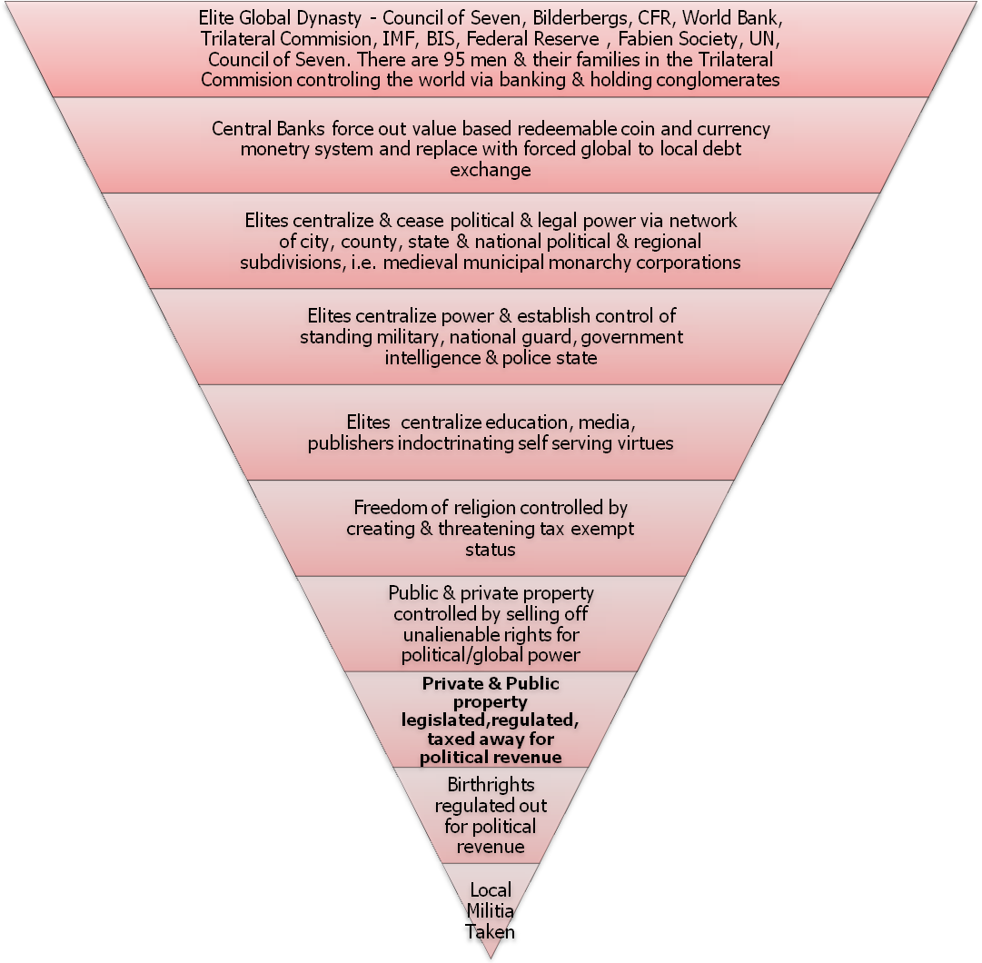
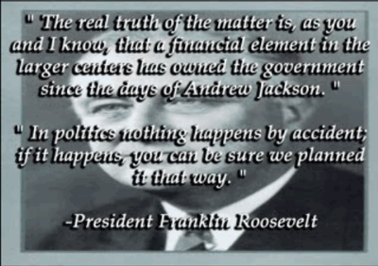
“The real truth of the matter is, as you and I know that a financial element in the larger centers has owned the government since the days of Andrew Jackson. In politics nothing happens by accident; if it happens, you can be sure we planned it that way. “President Franklin Roosevelt
“The poor victims being laughed at are the American people. Just as if they were so many farm animals, tens of millions of our fellow citizens are being lured by carrots held in front of them, and driven by sticks wielded behind, into the corral of slavery and slaughter. The Insiders find this very funny…There has seemed to be no end to the gullibility, the apathy, and even the blind cupidity of these vast herds of sheep which follow so readily the Judas goats that have been skillfully scattered among them. We need to pause for a few minutes to look at some of the evidence.” Robert Welch, October 1970 Bulletin

“Something has to die in order for us to begin to know our truths.”
Adrienne Rich

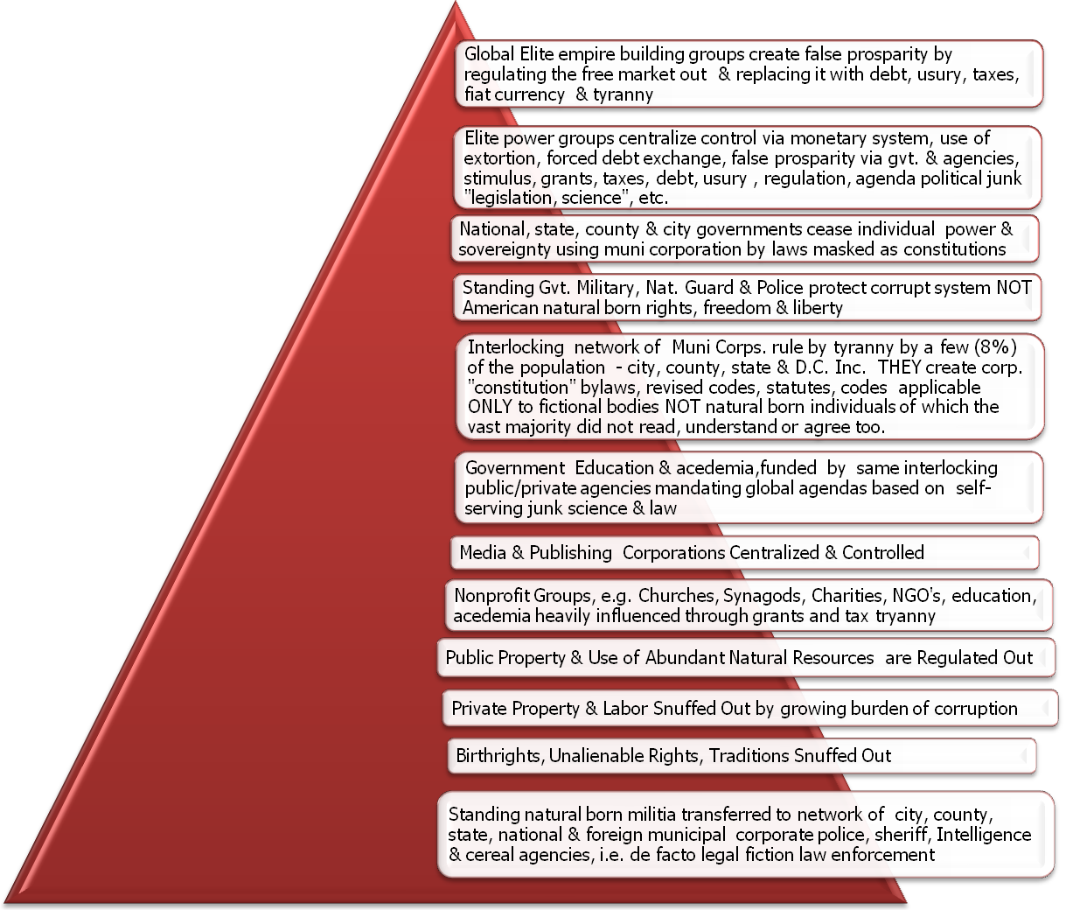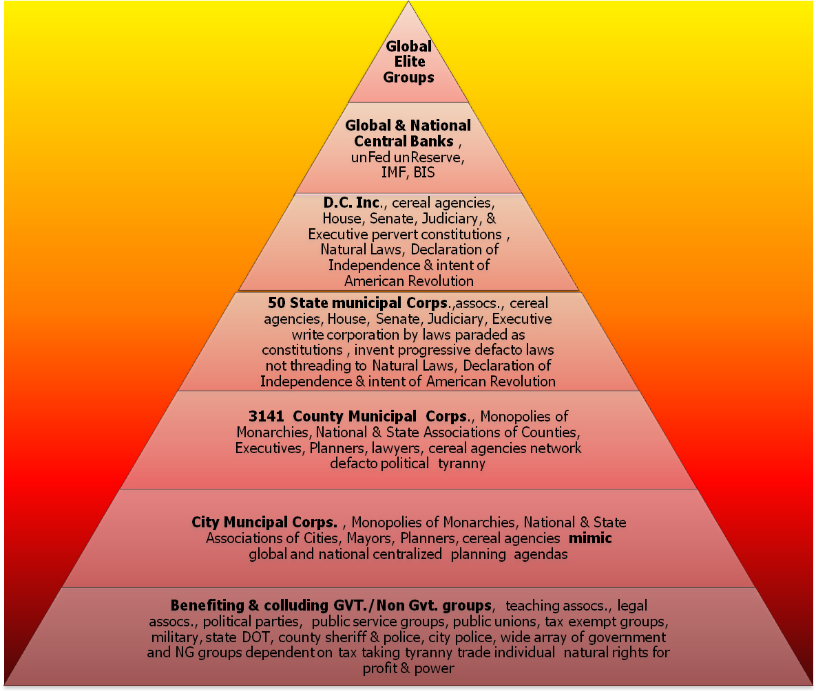
II. View 2 - Current Hierarchy Begets a Cascade of Taking Property
Debased On Force & Deception

Distribution of Force & Deception
"The few who understand the system, will either be so interested in its profits, or so dependent on its favors that there will be no opposition from that class, while on the other hand, the great body of people, mentally incapable of comprehending the tremendous advantages...will bear its burden without complaint,..and perhaps without suspecting that the system is inimical (Injurious or harmful in effect; adverse) to their best interests."
Rothschild Brothers
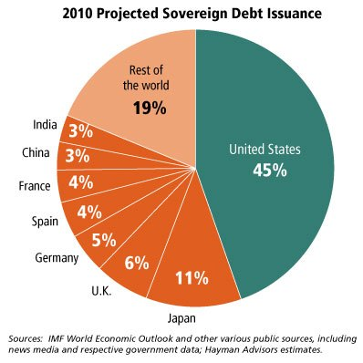
“The Council of Foreign Relations, established in New York on July 29, 1921, was a front for J.P. Morgan and Company (in itself a front for Rothschild banking) in associations with this country’s American Round Table Group.
..Since 1925, substantial contributions from wealthy individuals and foundations associated with the international banking fraternity have financed the activities of Round Table groups know as the Council on Foreign Relations.

By controlling government through the CFR, the power brokers are able to control America’s economy, politics, law, education and day to day subsistence….The CFR is an extension of the old world imperialistic British oligarchy.”

Dr. James W. Wardner, author of the book “The Planned Destruction of America

II. View 3 - Current Hierarchy (Overlays) of Top Seven Crime Groups Exploiting Individual Unalienable Rights
"The high office of the President has been used to foment a plot to destroy the Americans freedom and before I leave office I must inform the Citizen of his plight."
President John F. Kennedy (10 days before he was murdered)
“Humankind cannot bear very
much reality” –
T. S. Eliot

Force/Deception Distribution
“CORPORATION, n. An ingenious device for obtaining individual profit without individual responsibility.” Devil’s Dictionary
“{The Constitution} guarenteed they’d labor under a delusion, because as long as men believe they are free, they don’t have to actually be free”
M. Tsarion,Weapons of Mass Destruction Found, An Address To The Dead

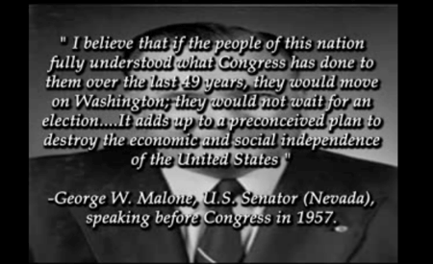
"The Constitution does not extend and authorize what the Declaration of Independence condemned".
Inferred from “Treaties and the Constitution”
"The Constitution is not an instrument for the government to restrain the people; it is an instrument for the people to restrain the government."
Patrick Henry
“If you would be a real seeker after truth, it is necessary that at least once in your life you doubt, as far as possible, all things.
Rene Descartes

II. View 4 – How the Books Were Cooked And How They Locked You Up Thru Mass Deception –
By Cascading, Centralizing & Networking Public & Private Corporation’s Using Self Bestowed Powers
“I believe that if the people of this nation fully understood what Congress {and all the states, counties & cities} has done to them over the last 49 years, they would move on Washington, they would not wait for an election….It adds up to a preconceived plan to destroy the economic and social independence of the United States.”
George W. Malone, U.S. Senator (Nevada), speaking before congress in 1957 {FreedomForAllSeasons note}
II. View 5 - The “Unseen” Collateral Damage of Government Administrative Cereal Agencies Using Forced Compliance
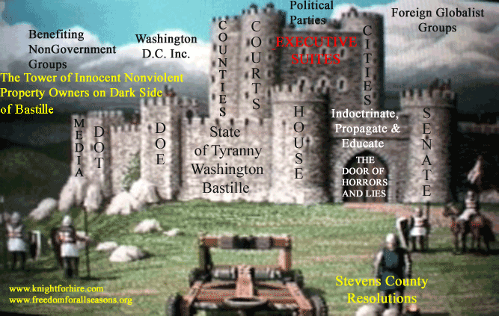
“The thing about Zen is that it pushes contradictions to their ultimate limit where one has to choose between madness and innocence. And Zen suggests that we may be driving toward one or the other on a cosmic scale. Driving toward them because, one way or the other, as madmen or innocents, we are already there. It might be good to open our eyes and see. Thomas Merton

“A majority of the people of the United States have lived all of their lives under emergency rule. For 40 years, freedoms and governmental procedures guaranteed by the Constitution have in varying degrees been abridged by laws brought into force by states of national emergency…” Senate Report 93-549: Introduction, Pg. 1

"Although it is unpleasant to acknowledge, we are caught up in an invisible war. We are being tricked and, in many cases, we can't see the game. It follows that if we don't know we're being 'played,' we won't know how to protect ourselves. My goal is to remove the barriers that prevent you from seeing this game...
Catherine Austin Fitts
II. View 6 - State of Washington Department of Ecology 2 Year Budget -
One Billion Dollars of Junk Green Political AGENDA “Science” Funded by Debt & Oppression
on Individual Property Owners, Families & Local Businesses Who Individually Never Approved These Takings
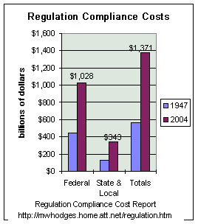
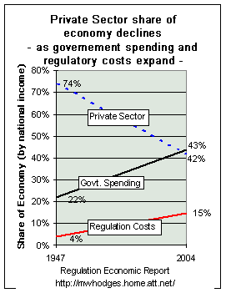
These programs may appear to be noble, but they are largely unsolicited by the private sector, extremely uneconomical and would not exist but by forced usury, debt, taxes and global political junk agenda “science” & collusion. A free market and a free Republic would never support this budget by extortion. The true and honest noble path to keep the environment clean is by free choice not by political environmental extremism. Good people are driven out of their homes, businesses and the state by this tyrannical agency. FreedomForAllSeasons
F

“If ever this vast country is brought under a single government, it will be one of the most extensive corruptions”... Thomas Jefferson

State of Washington 2 Year Financial Waste NOT Spent Cleaning Up THEIR Own Waste
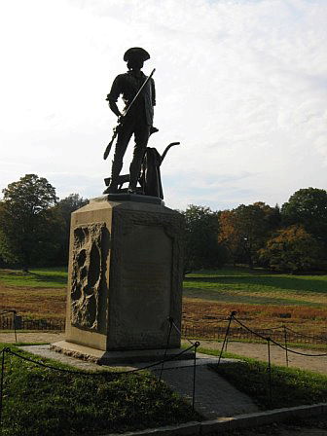
II. View 7 - The Global To Local Government & Non Government Colluding Agenda and Property Taking Funding Paradigm

- Local property owners are given ceremonial “comment periods” after the global to local grand agenda has long been funded and set.
- True and honest independent scientists and engineers are not consulted & rebuffed outside of this green global to local Matrix.
- Fundamental and founding laws of the land are totally ignored and replaced with progressive “laws” which are legislative lies having no basis in truth.
- America is a free Republic based on free choice NOT on colluding government and NG agendas based on lies & tyranny.
- A matrix of lies & deceit is created using global to local massive debt funding by steam rolling over individual life, liberty, private & public property & rights.
- Individuals & communities who want to keep full use of all their private & public property unregulated are forced to comply while they fight it out in the political “corrupt court system.
II. View 8 - Hierarchy of Current Era of Global Manipulation by De Facto Lawmaking Using Force
Distribution of Power
How Current Era Laws Are Created and Enforced By Force
“The central banking-warfare investment model” is really a control model, through which a small group of people can control the most resources on the most profitable basis. Essentially what happens is: Central banks print money and then the military makes sure those other parties accept it and that the financial system continues to have liquidity.”
Catherine Austin Fitts
Board of Directors Dillon, Read & Co., Inc
Past Assistant Secretary of Housing & Federal Housing Commissioner at HUD
President and founder of The Hamilton
Securities Group, Inc
BA University of Pennsylvania
MBA from the Wharton School
Studied Chinese at the Chinese University of Hong Kong.
There is a global war upon your local individual divine rights taking your private & public sanctuary. The dark side considers the American natural born an indentured employee of THEIR private and public corporations. They have written out & ignored the higher laws of the land and your power to rule on the laws. These private and public corporations have NO rightful power, authority or jurisdiction over YOUR private or YOUR public property. They only rule by force and deception. Few understand this massive Ponzi scheme.
Freedom For All Seasons

“Some of the biggest men in the United States, in the field of commerce and manufacture are afraid of something. They know that there is a power somewhere so organized, so complete, and so pervasive, that they had better not speak above their breath when they speak in condemnation of it”. President Woodrow Wilson
“I am a most unhappy man; I have unwittingly ruined my country. A great industrial nation is controlled by its system of credit. Our system of credit is concentrated. The growth of the nation, therefore, and all our activities are in the hands of a few men. We have come to be one of the worst ruled, one of the most completely controlled and dominated governments in the civilized world. No longer a government by free opinion, no longer a government by conviction and the vote of the majority, but a government by the opinion and duress of a small groups of dominant men.”
President Woodrow Wilson
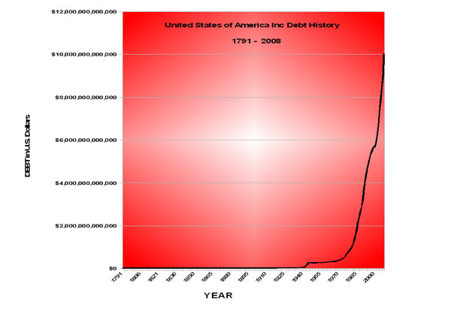
“On July 16, 1996 the Senate Committee on governmental Affairs held hearings considering a bill to require Congress to specify for each new law which section of the Constitution gives {them} authority to pass the law. Sen. Glenn [D-OH] spoke out strongly against this requirement stating, “Why if we had to do that we could not pass most of the laws we enact here.”He stated that the Clean Water Act, Endangered Species Act, the Americans with Disabilities Act and others could never have been passed if Congress had to find authority for them in the constitution.” Glenn declared “Americans just want us to solve America’s problems of health and safety and not be concerned if they can be constitutionally justified.”
Sen. Glenn [D-OH]

“In a dark time, the eye begins to see.”
Theodore Roethke

II. View 9 – The Vicious Cycle of Tyranny by the Corporate State (Federal, State, County, City Corporations)
II. View 10 - The Lifetime Costs of Government & Bank Extortion on Property Owners
(Click on title to link to Excel spread sheet & assumptions used)
“We have plenty of rights in this country, provided you don't get caught exercising them” -
Terry Mitchell
(Editor of The Revolutionary Toker)

“If you correct your mind, the rest of your life will fall into place.”
Lao Tzu

III. View 1 - True & Honest Free Republics are Based on Love (Individual Sovereignty & Free Choice)
NOT Fear, Attack, Divisiveness, Intimidation, Debt, Usury, Regulation, Taxes & Force

The source of this beautiful conceptual drawing has been misplaced, please forward if you know.
“Even if our efforts of attention seem for years to be producing no result, one day a light that is in exact proportion to your efforts, will flood the soul.
Simone Weil

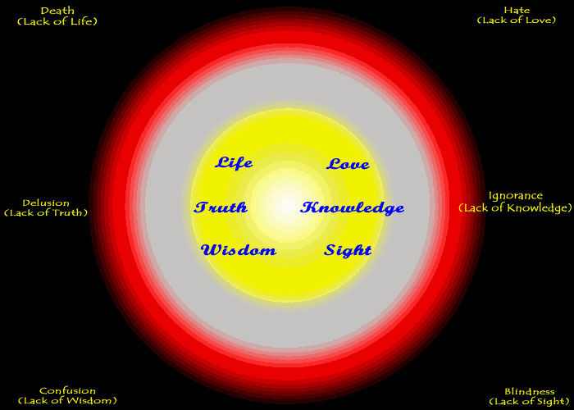
“One day, soon after his enlightenment, the Budda was walking toward a man who, while not knowing who he was, could see that there was something different about him. The man came closer and asked the Buddha:
“Are you a god?”
“No,” the Buddha replied.
“Are you a magician, then?
“A sorcerer?”
“No.”
“Are you an angel?"
“ Some sort of celestial being?”
“The Buddha again answered, “No”.
“What are you then?”,
the man asked.
The Buddha replied:"
“I am awake.”

FREE CHOICE FOR ALL STATE CITIZENS
III. View 2 - A True & Honest Hierarchy of American Independent States
Power Distribution
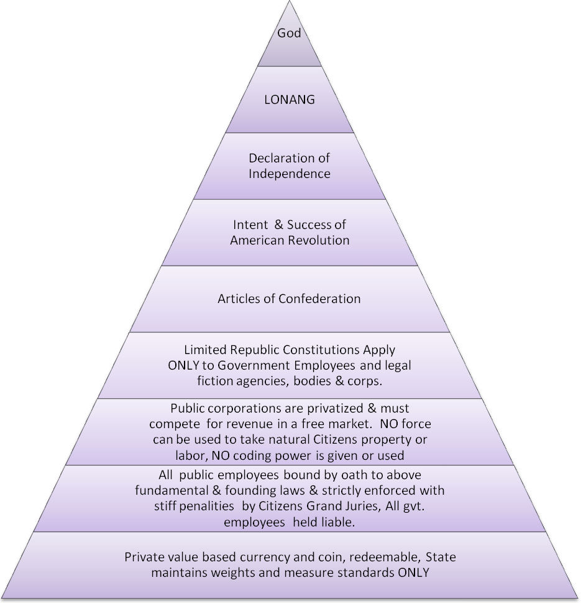
“Limited Republics limit only public and private corporations, the state Citizens are unlimited, free and sovereign.”
FreedomForAllSeasons
LONANG = Laws of Nature and Nature’s God
A True & Honest Hierarchy of American Independent States – View 4
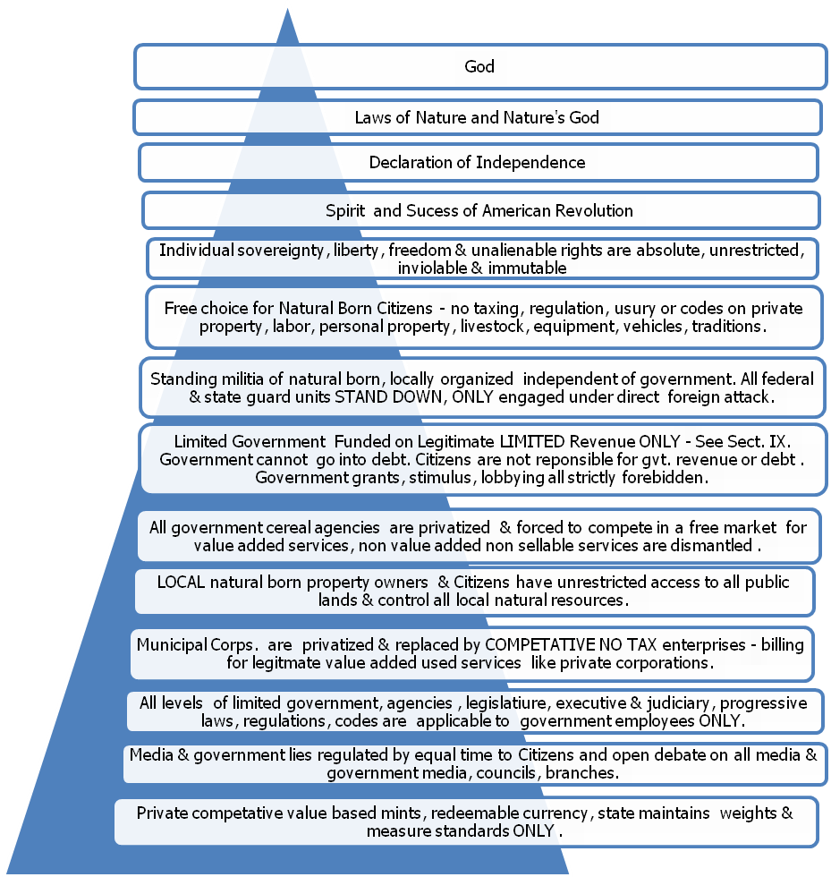
III. View 3 - A True & Honest Hierarchy of American Independent States

“The best way to make your dreams come true is to wake up”.
Paul Valery

FREE CHOICE FOR ALL STATE CITIZENS
Power Distribution
Current Hierarchy of Control
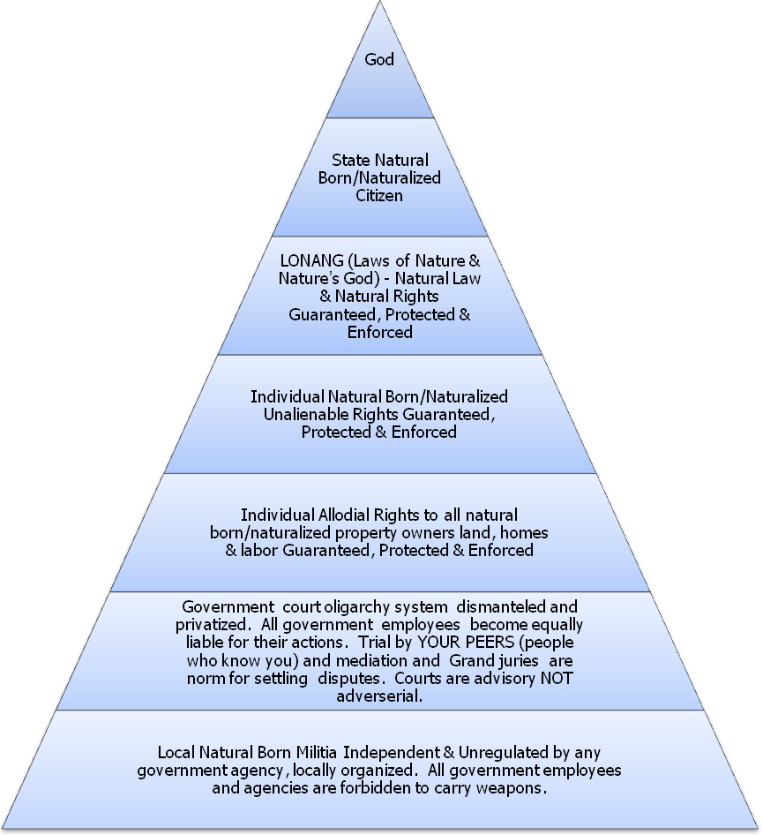
“To shift into true and honest individual freedom we must first release old belief systems of the role of public corporations and political subdivisions in our private lives, private property and unalienable rights.
FreedomForAllSeasons
Power Distribution
III. View 4 - A True & Honest American Natural Born/Naturalized Hierarchy of INDIVIDUAL Power
“To enter one’s own self, it is necessary to go armed to the teeth.”
Paul Valery

FREE CHOICE FOR ALL STATE CITIZENS

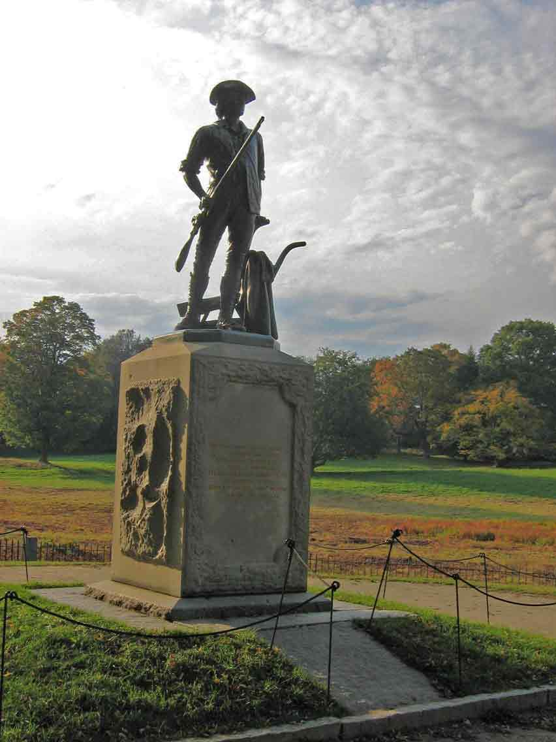
A TRUE AND HONEST REPUBLIC IS A FIREWALL OF FUNDAMENTAL AND FOUNDING UNCHANGING TRUTHS SEPARATING THE NATURAL BORN STATE CITIZEN COMPLETELY & ABSOLUTELY FROM ALL MAN MADE PUBLIC & PRIVATE CHARTERS & CORPORATIONS
American Citizens may be billed for services they directly and personally contract for. They can never be taxed directly or indirectly as they already pay all taxes for the private and public corporations when they purchase their goods and services by free choice.
Manmade private or public organizations including bodies of unelected or “elected” citizens serving the public are given no power, authority or rights to lord over natural born Citizens. “Lord over” includes zoning, regulating, representing, eminent domain, taxing, usury, takings of any kind for any reason. Free Citizens freely contract with each other but are never forced to “contract” with predatory agencies. Private and public corporations may properly discipline THEIR employees but NOT the natural born Citizens. Jury of our peers disciplines the natural born NOT self serving public cereal operational agencies who have no power in a free republic. The old ways of “governing” must all be discarded.
Essentials of Panarchism (free choices in communities NOT forced municipal monarchy monopolies - http://lewrockwell.com/rozeff/rozeff300.html
An American Natural Born INDIVIDUAL IS:
- Sovereign, Independent, FREE & FEARED
- A True & Honest Republic Is Established To:
- Protect & Preserve These Divine Rights at ALL cost, e.g.
  - ALL Individual Unalienable Rights,
  - ALL Allodial Rights,
  - ALL NATURAL LAW & NATURAL RIGHTS,
  - Individual SOVEREIGNTY, Free Will & Free Choice,
  - Liberty and Freedom
- This is clearly set forth in the highest fundamental & founding charters & action of this Land, i.e. (1) LONANG, (2) Declaration of Independence, (3) success & intent of the American Revolution.
III. View 5 - Individual Sovereignty – A Firewall in a True & Honest Republic
Union of States
Independent
No Taxes on Citizens, Competitive, Voluntary, Value Based Mints

States
Independent
No Taxes on Citizens, Competitive, Voluntary, Value Based Mints

Townships
Independent
Private Enterprises,
No Taxes on Citizens, Competitive & Voluntary

Cities
Independent
Private Enterprises,
No Taxes on Citizens, Competitive & Voluntary
III. View 6 - A True & Honest Republic Based on Individual Power vs. Elite Force Ruled Democracy
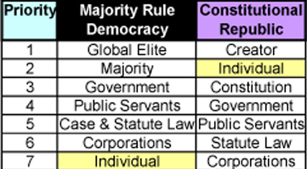
Characteristics of a True & Honest Republic
- The natural born & naturalized state Citizens are the sovereign Kings and Queens.
- American state Citizens INDIVIDUALLY hold ALL power.
- Individual power & force cannot be “represented or delegated” to anyone.
- All unalienable rights are secured and protected at ALL times, they cannot be legislated, administrated or adjudicated away.
- All private land is allodial, inviolable, immutable, indisputable, unrestricted, unqualified and absolute.
- Public land is controlled by ALL local Citizens, NOT by political councils, cereal agencies or environmental extremists.
- Free Citizens cannot be bound by adhesion contracts, e.g. social engineering, licensing, codes, etc. for any reason.
- Majorities, minorities & special interests groups cannot vote their own self interest to take property or labor for any reason.
- Government agencies have NO authority or jurisdiction over lives, traditions, property or rights of American natural born.
- Government & non government bodies ONLY have authority over their own employees.
- Municipal corporations & THEIR cereal agencies have NO more power, force or standing than a private corporation.
- Municipalities illegitimately mirror British monarchy monopolies which reverse “the divine rights of kings” against free Citizens.
- Government employees are NOT exempt from liability for their abuse of oath, taxing, taking, usury, debt, regulating, coding.
- Mayors, councils, executives, politicians, lawyers, bankers & lobbies cannot be judges & juries in their own creations.
- ALL Government cereal agency dynasties are dismantled, defunded and privatized, e.g. DOT, DOE, EPA, US Park Service, and USPS.
- The current network of government agencies, executives, councils, mayors & governors are stripped of ALL power & force.
- Government employees are prohibited to entangle America in any national or global agendas including environment & wars.
- Republics are established to protect individual Citizens NOT enslave them thru political, legal & ‘scientific’ junk agendas.
- All legislation, administration & judicial decisions MUST thread to the highest fundamental & founding laws of the land.
- All legislation, administration & judicial decisions are absolutely and completely voluntary.
- Without above guarantees, Citizens are held hostage by self serving political, legal, monetary & financial factions.
  - i.e., We are either all free OR we are all enslaved
“How terrible to watch a man, who has the incomprehensible within his grasp, doesn’t know what to do, and sits down playing with a toy called God.”
Feodor Dostoyevsky

IV. View 1 - How Power Was Transferred from the Natural Born Individual
to Artificial Political Legal Fiction Municipal Corporations

“The desire of power in excess caused the angels to fall; the desire of knowledge in excess caused man to fall.” Francis Bacon

"The incorporation of cities and towns by special act of the legislature has, in many instances, proven to be a fountain of evil in the states where it prevails. There is no branch of government more completely adapted to the purposes of those who make the filthiest a trade than the manipulation of city charters, where their enactment is controlled by special laws." The Origin of The Constitution of The State of Washington, by Lebbeus J. Knapp, page 16. This report was prepared as a thesis for the Master of Arts degree in the University of Washington. The debates and proceedings of the convention were never published. Mr. Knapp gleaned information from survivors of the convention and newspapers of that day.
http://www.freedomforallseasons.org/FreedomFromTheStateofWashingtonCONstitutionThatNeverWas.asp

The natural born Citizens did NOT give the politicians, lawyers or bankers any power. The national, state, county and city appointed executives, their lawyers and bankers bestowed this power upon themselves for their own power and profit with the necessary use of manipulated charters (corporate bylaws) and manipulated “votes” of a few. The vast majority knew no difference.

The politicians and lawyers wrote up their own charters and signed it themselves. Relative few Citizens understood, agreed or signed these parchments. Did you or your ancestors sign any of these charters, of course not! Lysander Spooner saw this in the mid 1800’s.

The dark side of municipal corporations have not only "exceeded their power by very far", they have fabricated absurdities and atrocities against property and business owners which rightfully ONLY apply to the employees of the municipal corporations themselves. This trick is the shell game used throughout the state constitutional conventions.

The political and legal elites shifted power from the individual natural born state Citizens to themselves by creating their own charters giving legal fiction faux power to a network of municipal corporations with the equivalent of “Divine Rights of Kings”. This is strictly forbidden in the Laws of Nature and Nature’s God, the Declaration of Independence and the action and success of the American Revolution. The organization structure of municipalities is long out of date and debased on oppression and the “divine right of kings”.

True and honest Constitutional Republics or Consolidated Republics, prevent and severely punish this empire building. Again, we see the lineage of British monarchy feudal tyranny threading through American founding charters. This negative heritage was NOT severed after the success of the American Revolution in the Battle of Yorktown in October 19, 1781.

“Therefore the very idea of a lawmaking government --- a government that is to make laws of its own invention --- is necessarily in direct and inevitable conflict with "our liberty." In fact, the whole, sole, and only real purpose of any lawmaking government whatever is to take from some one or more persons their "liberty." Consequently the only way in which all men can preserve their "liberty," is not to have any lawmaking government at all.” Lysander Spooner

“Humankind cannot bear very much reality” T. S. Eliot

IV. View 2 – The Vicious Global to Local Municipal Cycle
When a well-packaged web of lies has been sold gradually to the masses over generations, the truth will seem utterly preposterous and its speaker a raving lunatic". Dresden James, Author
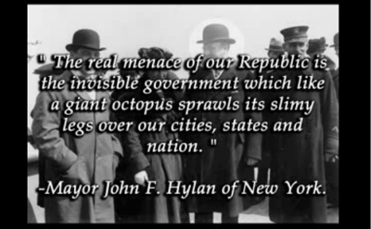

Federal + State Bribery & Conditional
Grants
Federal
Bribery & Conditional Grants
Federal
Bribery & Conditional Grants
Federal + State+ County
Bribery & Conditional
Grants
“The real menace of our Republic is the invisible government which like a giant octopus sprawls its slimy legs over our cities, states and nation” Mayor Hylan N.Y.C.
$$$$$$
Extortion & Torture of Individuals,
Families & Local
Businesses
$$$$$$$$
Extortion & Torture of
Individuals, Families & Local
Businesses
$$$$$$
Extortion & Torture of Individuals,
Families & Local Businesses
$$$$$$$
Extortion & Torture of Individuals,
Families & Local Business
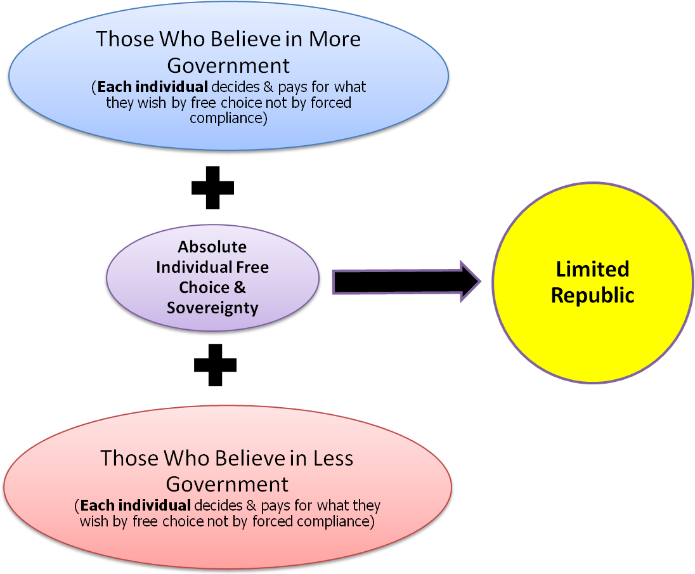
“The only real "sovereignty," or right of "sovereignty," in this or any other country, is that right of sovereignty which each and every human being has over his or her own person and property, so long as he or she obeys the one law of justice towards the person and property of every other human being. This is the only natural right of sovereignty that was ever known among men. All other so-called rights of sovereignty are simply the usurpations of impostors, conspirators, robbers, tyrants, and murderers.”
Lysander Spooner
“This system of false definitions, false assumptions, and fraud and usurpation generally, runs through all the operations of our governments, State and national. There is nothing genuine, nothing real, nothing true, nothing honest, to be found in any of them. They all proceed upon the principle, that governments have all power, and the people no rights.”
Lysander Spooner
IV. View 3 - More + Less + Free Choice = Limited Government
"In subsequent numbers, the author hopes to show that, under the principle of individual consent, the little government that mankind need, is not only practicable, but natural and easy; and that the Constitution of the United States authorizes no government, except one depending wholly on voluntary support." Lysander Spooner, No Treason No. I. The Constitution 1867
V. View 1 - Reasons Why “Representative” Systems of “Government” Inherently Destroy Individual Free Choice

“Inanimate objects (e.g. ball bearings) & simple minded agenda political & marketing studies may be sampled & thus “represented”. However, it is an absurdity to believe that individual freedom, liberty, property and unalienable rights can be “represented” through any political processes.” FreedomForAllSeasons
“The very act of observing disturbs the system.”
Werner Heisenberg, The Heisenberg Principal

This page is a free teaser download on this site:
http://www.research-advisors.com/tools/SampleSize.htm
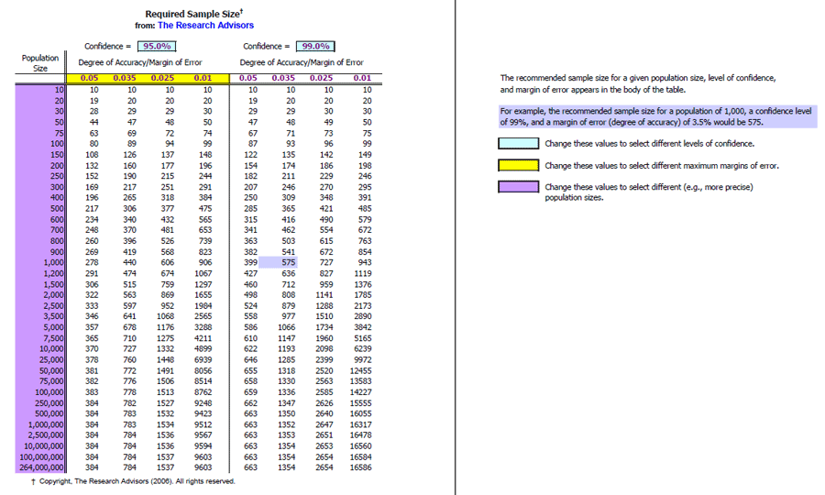
V. View 2 - Reasons Why “Representative” Systems of “Government” Inherently Destroy Individual Free Choice (Cont.)

“Representative” “governments” are predestined to FAIL because… (note: representative include any government employee,
especially representatives, senators, executives, mayors, council members, judiciary and non government bodies who claim too)
- Individual sovereignty, rights & power cannot be delegated or represented to anyone or by anyone, they are endowed by God.
- How can a “Representative” represent you, when they do not understand and sell out the highest fundamental and founding laws of the land, i.e. Laws of Nature and Nature’s God, the Declaration of Independence and the success and intent of the American Revolution?
- “Representative” systems of “government” are in reality representative of ego, power & greed using thuggery & force disguised as “legislation”.
- Manmade charters claiming supremacy or power over Citizens without individual consent are crimes against the Citizens and a free society.
- The Laws of Nature & Nature’s God is the Supreme Laws of the land NOT the charters or branches of the central banker’s government.
- “No law making power can be safely entrusted or represented to anybody for any purpose whatever.” Lysander Spooner
- Manmade “governments” are designed to transfer & centralize power & force to special interest groups thru deception & lies.
- Manmade government is created to transfer power by force from the natural born to self serving politicians, lawyers & bankers by design.
- History confirms the American “limited government” has not worked, especially when individual sovereignty is intentionally designed out.
- Many American Revolutionaries foretold these high truths & history has confirmed them correct, e.g. Jefferson & Paine.
11) The transfer of individual sovereignty and power to date was designed into the U.S. constitution AND state constitutions.
12) All American charters EXCEPT the Declaration of Independence and LONANG (Laws of Nature & Nature’s God) were poisoned.
13) “Divine Rights of Kings” was seeded into the founding charters by special interest groups.
14) So called “constitutional limited governments” are in name only and is a tool of special interests to centralize power.
15) Fuzzy concepts such as “representative” , “constitutional”, “republic”, “limited” are blue pills (blissful ignorance of glamour & illusion) versus the red pill of reality herein (embracing the hard truth) using the “Matrix” movie series theme.
16) "Judges have been given the "power to {ONLY} interpret" the law. Ours is an "adversary system" of justice. Ours is a "common law" based system of jurisprudence. The STATE is the sovereign, immune from [law] suit or liability; public servants are Immune is the BIGGEST MYTH OF ALL."www.informed.org
17) A "representative" model of government represents the municipal & private corporations, their associations and lobbyist foremost, NOT the highest founding & fundamental charters protecting your INDIVIDUAL life, liberty & property.
18) The act of “Representation” transfers individual power and sovereignty away from the individual which is an act of taking in itself.
19) The current “representative” form of government is an oligopoly representing limited choices of enslavement.
20) The current representative system is designed to TAKE individual freedom & liberty by allowing vote differentials to speak for everyone whether “everyone” is the “majority” or the “minority” vs. a free individual who does not want what is imposed on the herd.
21) Representatives need to be thoroughly trained & sworn to the fundamental & founding laws of the land ABOVE the constitutions/corporate state bylaws, i.e. LONANG, the Declaration of Independence & the spirit and intent of the American Revolution BEFORE they take office.
22) Representatives do not know who they represent personally, nor can they, because the ratio of people they claim to represent is too large.
23) Representatives have misrepresented American precious uniqueness & traditions into a nation of franchised “Stepford” municipalities.

“If you can doubt at points where other people find no impulse to doubt, you are making progress.” Chuang-Tzu
24) “Hayek questioned the ethics of a system “in which it is not a majority of givers who determine what should be given to the unfortunate few, but a majority of takers who decide what they will take from a wealthier minority”.
25) It is more a rule than an exception for politicians to say one thing and do another, the current level of tyranny speaks to this.
26) “Limiting” “government” is not unlike “limiting wars”, “limiting growth”, limited endangered species”, “limiting water”, “limiting global warming”, “limiting natural resource usage”, “limiting behavior”, “limiting development”, a.k.a. “sustaining development”, etc.
27) It is statistically impossible to “represent” human unalienable rights because they are divinely bestowed at birth, i.e. they are given not represented.
28) Artificial legal fiction corporations may be represented because they are like ball bearings and are not natural.
29) Gross natural phenomena may be statistically represented with accuracy, however individual natural born are divinely bestowed to be infinitely unique and cannot by their very nature be “represented”.
30) If you believe you have “elected” “representatives”, with the powers you believe you transferred to them, you have empowered them to enslave you.
31) The concept that representatives were given the power over your life, property, wages, health, retirement, traditions, family & business is another absurdity on top of the hypocrisy; they have the right to “represent” your birthrights at all.
32 The act of “representing” so called majorities & minorities is like herding buffalo, where the direction over the cliff is premeditated by political agenda and ego with little to no input from the natural born Citizens.
33) Representatives are controlled by the mandates of the political parties, sources of debt funding & the continual centralization of power.
34) Representatives have little control over the inertia of topside heavy global to local hierarchy of greed, deception and power.
35) The very act of “representation” has led America to not only being misrepresented, but has led to the creation of a massive predatory “constitutional representative democratic dynasty”.
36) “Representation” current era enslaves Citizens with an overwhelming stream of illegitimate regulations, taxes, debt, usury, bankruptcy & foreclosure few Citizens can understand, let alone find free air to breathe.
37) The intention and skill of the representative may be avatar like, but the illegitimacy of the machinery is the death knell to freedom.
38) The universes are held together by divine laws, one of which is free choice & individual consent which cannot be perverted for long.
39) To hold hundreds of millions of people hostage in a feudal monarchy system of tyranny and pretend they are “represented”, “free” and “vote” is a shocking statement of absurdity.
40) Conversely, those representatives & senators who comprehend this message fully will be charged with the duty to return the power stolen from the individual natural born American to the true and honest sovereigns in this land, the American natural born.
41) Representatives in a true and honest republic cannot bind the natural born sons and daughters of the land; they assure they are completely & absolutely free by threading all legislation to the highest fundamental and founding laws of the land.
43) More “representative” legislation is done in back room deals without Citizen knowledge, than otherwise. Conversely, so called “representative” government is an agenda dialectic giving its victims several bad choices while intentionally not addressing the core issues.

V. View 3 - Reasons Why “Representative” Systems of “Government” Inherently Destroy Individual Free Choice (Cont.)

“The system is rigged. You can’t win by joining a political party or forming a new party. During the last 100 years the two major parties have discouraged many voters because they have made it very difficult… for those who oppose the status quo. “The CONstitution That Never Was”, R. Boryszewski
V. View 4 - Reasons Why “Representative” Systems of “Government” Inherently Destroy Individual Free Choice (Cont.)

44) Representatives have lost control of themselves, the cereal agencies, the courts & the executive branches.
45) Representatives cannot give or represent charity or love or welfare as government officials. This is not the role of a true & honest republic. Only humans can give love from one individual heart to another. Private charities, churches, synagogues & local communities may give charity.
46) Representatives are not in touch directly or indirectly with the INDIVIDUAL natural born except for a “vote” or campaign donation.
47) Representatives have forgotten and/or ignore American’s most sacred & highest fundamental and founding laws of the land.
48) Representatives have sold out to the corrupt BAR, municipal associations, judicial progressive de facto “laws” & tax collection agencies.
49) Representatives have sold out to the central banks scheme of “grants” of debt in exchange for individual unalienable rights.
50) Representatives have breeched & violated the most sacred ring-pass-not of unalienable rights of the natural born.
51) The current global to local hierarchy of power has funded an avalanche of takings of the highest laws of the land.
52) Because Representatives have no liability or accountability for their actions and because the parties and system screen out true and honest free choice and because everything they “represent” is debased entirely on a system of monarchial monopolies of revenue by extortion and force, these people represent no one but themselves and the banksters, liewyers, political parties and self serving global to local public and private corporation shadow government parading as a dictatorship in republic clothing.
53 Representatives live in a world of “Sound of Silence” ignoring the highest fundamental and founding laws of the land thereby allowing and perpetuating a global to local massive taking of private and public property and our local traditions.
54) Even the best representatives are rendered ineffective after the highest fundamental and founding laws of the land are ignored.
55) This massive global to local Brotherhood of Darkness have hypnotized most of the representatives and the state Citizens to believe that stealing (e.g. regulating, taxing, usury) private and public property is necessary, acceptable and glamorous.
56) “In short, they virtually say, that this government exists for itself alone; and that all the natural rights of the people, to property, liberty, and life, are mere baubles, to be disposed of, at its pleasure, whether in time of peace, or in war. “ Lysander Spooner
57) A so called “representative government” which is unable, unwillingly and even powerless to anchor the highest fundamental & founding laws of the land cannot claim it is representative, i.e. it is representative of a den of vipers not the American natural born.
58) Far too many representatives believe they have a duty to remold human nature. “Man is a rational animal, a social animal, a property owning animal and a maker of things. He is social in the way that wolves and penguins are social, not social in the way that bees are social. The kind of society that is right for bees, a totalitarian society, is not right for people. ...humans are social, but not eusocial" - http://encyclopedia.farlex.com/Eusocial
59) Political parties continually dismantle & redefine districts to suit their agenda, so one party and/or one urban area better controls the other.

“It wasn't the world being round that agitated people, but that the world wasn't flat.” Dresden James, Author

V. View 5 - Reasons Why “Representative” Systems of “Government” Inherently Destroy Individual Free Choice (Cont.)

Breaking the Rules to Rise to Power: How Norm Violators Gain Power in the Eyes of Others - Abstract
Powerful people often act at will, even if the resulting behavior is inappropriate—hence the famous proverb ‘‘power corrupts.’’
Here, we introduce the reverse phenomenon—violating norms signals power. Violating a norm implies that one has the power to
act according to one’s own volition in spite of situational constraints, which fuels perceptions of power. Four studies support this
hypothesis. Individuals who took coffee from another person’s can (Study 1), violated rules of bookkeeping (Study 2), dropped
cigarette ashes on the floor (Study 3), or put their feet on the table (Study 4) were perceived as more powerful than individuals
who did not show such behaviors. The effect was mediated by inferences of volitional capacity, and it replicated across different
methods (scenario, film clip, face-to-face interaction), different norm violations, and different indices of power (explicit measures,
expected emotions, and approach/inhibition tendencies). Implications for power, morality, and social hierarchy are discussed.
http://medicalxpress.com/news/2011-05-powerful.html
59) The act of representation does not convey power or authority from the individual American natural born nor does it authorize the use of power or authority of any kind for any reason over their individual sovereignty.
60) In a true & honest free republic the natural born may never be taxed; they may only be billed for services they personally contract.
61) Once a “representative” system of “government” removes free choice from the equation of freedom, individual freedom, liberty & unalienable rights are quickly taken by simple majorities & minorities who given the chance, will take at the expense of others.
62) Representatives have long ago lost control to the global to local manipulators before the quill penned the “constitutions”.
63) True and honest representation is done on an individual heart to heart basis NOT on political group levels through political agendas.
64) The American natural born & naturalized have no superiors, though many government & non government type servants like to pretend they are.
65) 80 to 99% of all legislation and the very organization of all levels of American government (cities, counties, states and federal) as well as THEIR colluding & complicit non government associations go against the highest fundamental and founding laws of the land, i.e. the Laws of Nature and Nature’s God, the spirit, intent and success of the American Revolution and the Declaration of Independence.
66) Once you allow one person or one private or public organization or one “government” to breech one of the highest fundamental and founding laws to take from one natural born or naturalized Citizen, you have created the hole in the dam which will destroy the nation.
67) Turning a blind eye on the highest laws of the land instantly redefines truth into legal fiction which in turn creates a cascading self fulfilling accelerating paradigm of takings over generations turning a free country into a slave state operated only by an exponential explosion of debt, usury, illegitimate taxes and false prosperity for profit and power by the few who have a stake in the takings.
68) The End of Representation: How Congress Stifles Electoral Competition – Check this link out too confirm this point out further.

Therefore the very idea of a lawmaking government necessarily implies a denial of all such things as individual liberty, or individual rights. Lysander Spooner

VI. The Top 10 Characteristics of Bottom-Up vs. Top-Down Societies
“A thing long expected takes the form of the unexpected when at last it comes.”
Mark Twain

“Self-reverence, self-knowledge, self-control – these three alone lead to sovereign power.” Alfred, Lord Tennyson
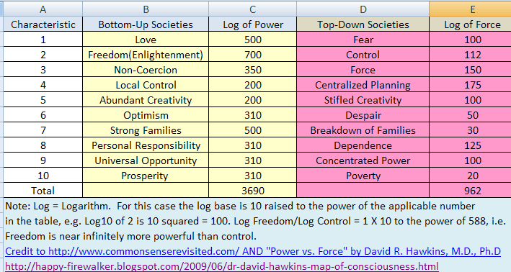

Applying Dr. David R. Hawkins “Power vs. Force” findings to www.Commonsenserevisted.com society types;
- A bottom-up society using individual power is 1 X 10 to 2,728 more powerful
compared to a top-down society based on force, i.e. infinitely more powerful.
VII. The Evolution of Self Rule – Systems of Centralized Force Evolving to Individual Power
Critical Mass
Awakens

E
V
O
L
U
T
I
O
N

OF

F
O
R
C
E
ERA OF FORCE
- Force & power is Centralized
- Deception & fear stampede the masses
- Criminal & innocent behavior blurred
- Wars & Foreign Entanglement
- Monetary & Economic Instability
- Bankruptcy of Muni. Corps.
- Confiscation of private & public property
- Increasing Global Elite Control
- UN Agenda 21
- Global Warming Lies
- Alternative Energy Lies
- Endangered Species Lies
- Environmental Lies
- Media & Education Lies
- Rapid Regulatory, Usury & Tax Taking
- Abandonment of Fundamental & Founding Laws of the Land
- Loss of Individual freedom, liberty, unalienable rights
“We can easily forgive a child who is afraid of the dark; the real tragedy of life is when men are afraid of the light.” Plato

ERA OF INDIVIDUAL POWER
- Individual free choice & consent
- Force used only on harden criminals
- Power & Sovereignty taken back by American Natural Born Citizens
- Muni Corps dismantled
- Executive offices force & power removed
- Government & non gvt. Agenda Councils dismantled
- Central Banking System dismantled
- Private value based mints restored in all states, competing coin & currency
- Government cereal agencies dismantled
- Government employees sworn to new oaths of higher laws of land under severe penalties
- Government employees become liable for any property damages they cause directly or indirectly
- Political grant funding ends
- Lobbying ends
- Police State Ends – All weapons of public law enforcement are transferred to local militias. Public law enforcement vehicles sold to public. Law enforcement returns to street beats
- Legislature, executive & judiciary serve for low or free and rotate for short terms for the honor not self
- Remaining government services which cannot compete in the free private market are dismantled
- All forced tax collections & regulations upon the natural born/naturalized are discontinued
E
V
O
L
U
T
I
O
N

OF

I
N
D
I
V
I
D
U
A
L

POWER
"Sovereign individuals are subject only to a Common Law, whose primary purposes are to protect and defend individual rights, and to prevent anyone, whether public official or private person, from violating the rights of other individuals. Within this scene, Sovereigns are never subject to their own creations, and the constitutional contract is such a creation." To quote the Supreme Court, "No fiction can make a natural born subject." Milvaine v. Coxe's Lessee, 8 U.S. 598 (1808). That is to say, no fiction, be it a corporation, a statute law, or an administrative regulation, can mutate a natural born Sovereign into someone who is subject to his own creations. http://www.supremelaw.org/fedzone11/htm/chaptr11.htm , page 8 of 20
VIII. Breaking Out of Municipal Corporate Political Subdivision Prison Camps in America

“The universe is like a safe to which there is a combination, but the combination is locked up in the safe.”
Peter De Vries

The Noble Path to a higher ground of peaceful coexistence may be summed up as follows
- All true and honest republics are based on INDIVIDUAL voluntary consent without coercion and agendas.
- All government public corporations and agencies are bound to free choice by the Laws of Nature and Nature’s God, the
Declaration of Independence and the success and spirit of the first American Revolution.
- Without individual free will and free choice, societies collapse on escalating use of fear, deception & force.
- Free communities and free individuals offer free choices NOT forced agendas.
- Free individuals who do not wish to participate in any form or level of government cannot be forced to comply.
- Majorities or special interest groups cannot force anyone to do anything without contracting with the individual(s)) directly after they are fully informed and without duress.
- So called “adhesion contracts” forcibly & deceptively applied do not bind natural born Citizens per the higher laws of land.
- Government branches, agencies, municipal corporations or non government groups cannot “legislate” one sided regional rulings using force upon individual natural born Citizens who do not agree to takings.
- Individuals and communities of individuals agree to covenants through voluntary consent NOT Forced Adhesion.
- Government employees, political parties, lawyers or bankers were never given sovereign power …
  - OVER FREE INDIVIDUAL AMERICAN NATURAL BORN OR NATURALIZED state CITIZENS
  - to separate property owners and wage earners from their private AND public property rights
  - to limit access to their private & public land, water, shorelines,
  - to control community or individual traditions and growth
- These self serving charters, bylaws & codes are written by political, legal & professional shysters
    - NOT by individuals who voluntary consented or by unanimous voluntary agreement.
- Legislation, administration and judicial rulings cannot be forced upon free natural born (adversarial vs. advisable)
- Manmade laws do NOT trump the higher fundamental and founding laws; the higher laws prevent & protect any takings.
- True & honest republics of states, counties & city government employees have NO immunity to liability.
- ALL power is held in the hands of the individual natural born or naturalized state CITIZEN.
- Municipal corporation political subdivisions cannot bind or hold Citizens by majority votes. Forcing natural born Citizens to stay and pay is a model of medieval tyranny.

IX. Legitimate vs. Illegitimate Taxes – View 1 - Chart Update: Lysander Spooner makes a good case against import duties, i.e. what goes around, comes around; also, private market mints which existed without problems in California gold mining days. www.freedomforallseasons.org/FreedomFromTaxesNew.dwt.asp

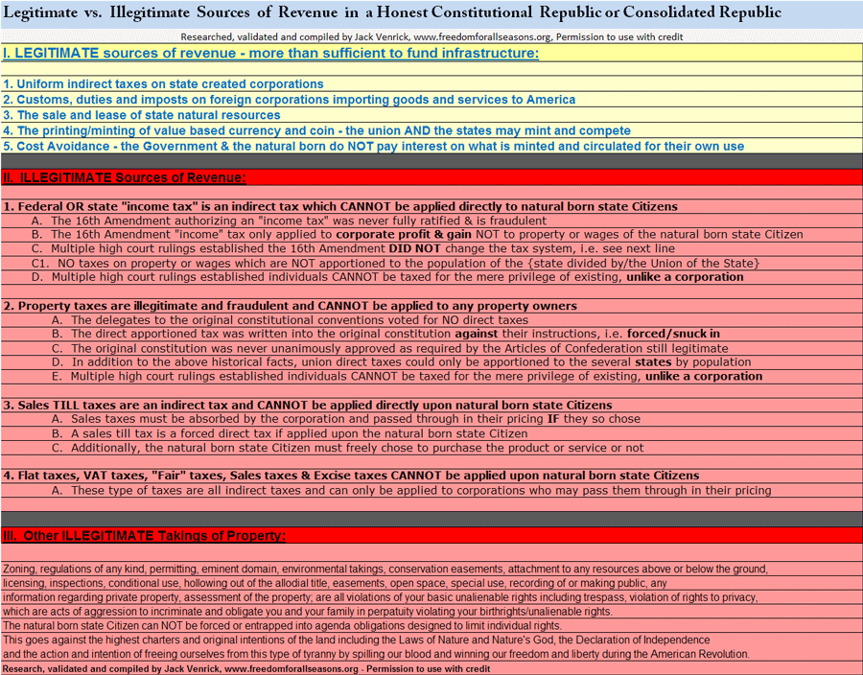
“Penetrating so many secrets, we cease to believe in the unknowable. But there it sits nevertheless, calmly licking its chops.”
H. L. Mencken

IX. Legitimate vs. Illegitimate Taxes – View 2 - How the CON Game Works
http://www.freedomforallseasons.org/FreedomFromALLTaxes.asp
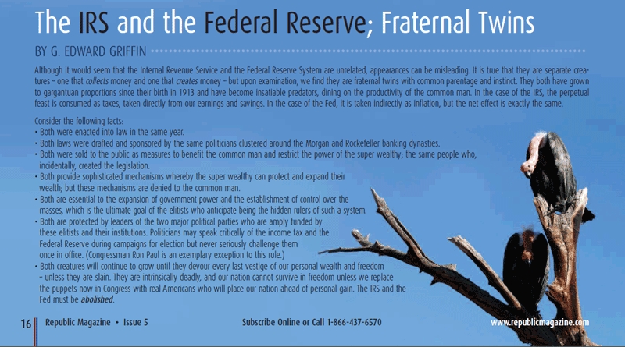
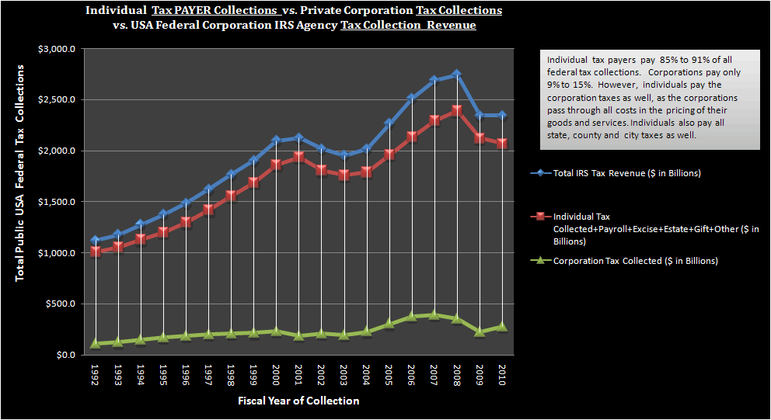
IX. Legitimate vs. Illegitimate Taxes – View 3 –Individual Tax Payer Collections vs. Private Corporation Tax Collections
www.freedomforallseasons.org
Individuals are slaves forced to pay all taxes for the public AND private corporations many times over. This goes against all the highest fundamental and founding laws of America, i.e. The Laws of Nature and Nature’s God, the Declaration of Independence and the intent and success of the first American Revolution. The natural born and naturalized state Citizens are free born and pay no taxes by force. They may pay taxes when they freely choose to purchase goods or services from a corporation, if the corporation passes it through. This is NOT a sales tax. It may be part of the cost of the product inherent in the price of the product or service at the choice of the corporation. No natural born, naturalized Citizen or family business can be taxed. Only artificial bodies created by man may be taxed. FreedomForAllSeasons
“The secret of seeing things as they are is to take off our colored spectacles. That being-as-it-is, with nothing extraordinary about it, nothing wonderful is the great wonder. The ability to see things normally is no small thing. To be really normal is to be unusual in that normality begins to bubble up inspirations. Master Sessan

IX. Legitimate vs. Illegitimate Taxes – View 4 – Individual vs. Corporate % of Wages & Revenue Taxes Paid

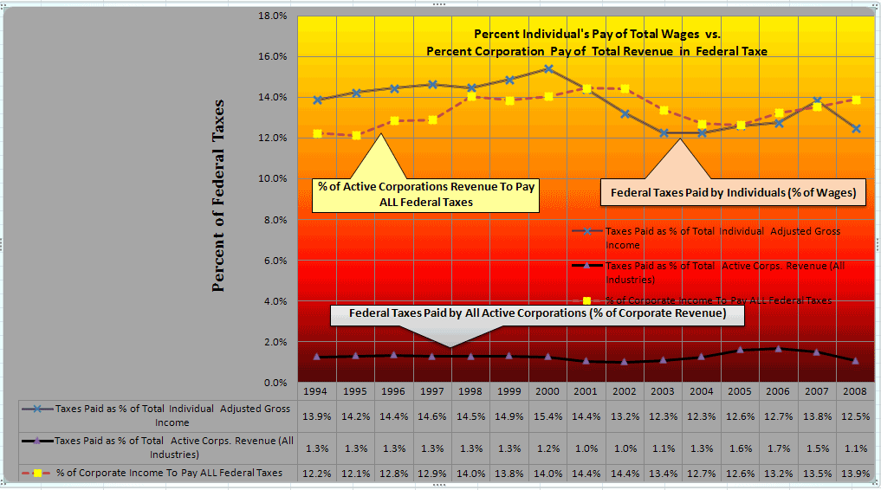
Summary of IX. View 3 and 4 Graphs
- Currently Individuals pay 12 - 14% of Wages for 85 to 91% of Federal Taxes
- Currently 1 % of Corporate Revenue Pay 9 - 15% of Federal Taxes
- Individual Federal taxes can be replaced by a 12 - 14% tax on Corporate Revenue
- Currently .17% of Corporate Revenue Pays State Taxes
- Currently 5.18% of Individual Payroll (Wages) Pays State Taxes
- Individual State taxes can be replaced by a 1.04% on Corporate Revenue
- All taxes are ultimately paid by the consumer when they purchase by free choice

www.freedomforallseasons.org
X. American Natural Born/Naturalized Individual Shield (Ring-Pass-Not) of Unalienable Rights -
Unalienable Rights are a Divine Sanctuary which is Inviolable, Immutable, Indisputable, Unrestricted, Unqualified and Absolute.
www.freedomforallseasons.org
XI. View 1 – Current Democratic Dynasties vs. True and Honest Limited Republics

“Government” Attribute | Current Era of  Democratic Dynasties | True & Honest  Limited Republics
1. Citizens are indoctrinated to believe they are free when they are ruled by majorities and minorities. | Yes | No
2. Citizens are taught to believe we live in a democracy not a republic where majority votes commit the minority who do not want any part of what the majority wants. | Yes | No
3. Individual Natural born & naturalized power is kidnapped by despotic government and globalist groups. | Yes | No
4. Multi-billion dollar government cereal agencies manipulate and are manipulated by outside extreme government and non government groups while pretending to solicit “citizens” concerns after agenda is set. | Yes | No
5. Natural born and naturalized Citizens are indoctrinated to believe political subdivisions and municipal corporations have the power to control them. | Yes | No
6. Natural born and naturalized Citizens are indoctrinated to believe government charters control them. | Yes | No
7. Citizens are forced to conform to an artificial dialectic created by the elite and state of two terrible choices. | Yes | No
8. Government is allowed to use the theory of adhesion contracts against the natural born/naturalized Citizens. | Yes | No
9. Government is allowed to go into debt and obligate the Citizens and use debt to create more tyranny. | Yes | No
10. Government is used by the central banks to launder crimes of usury, fiat currency and debt. | Yes | No
11. Globalist groups are allowed to short circuit America’s traditional processes. | Yes | No
12. All private & public property is confiscated by de facto legal, environmental & false flag “emergencies” to collateralize fraudulent debt, usury, wars, takings & growing police state. | Yes | No
13. Citizens are brain washed to believe they are responsible for artificial political subdivisions & municipal corporation’s acts of forced taxing, debt, tyrannical regulatory codes & use of armed police. | Yes | No
14. The state is allowed to expand itself into every industry, education including the manipulation of population, growth, water, shorelines, and public and private property and lives of every Citizen. | Yes | No
15. The fundamental and founding laws of the land are superseded by relative progressive manmade “laws” which do not thread to the highest laws of the land. | Yes | No
16. Local militias are replaced by local to global tyranny and a growing police state. | Yes | No
17. Government employees are allowed to become arrogant & despotic & believe they are given the divine rights of kings to rule over American natural free born while given no rights at all over Citizens. | Yes | No
18. Education, media, monetary, military and financial systems are held together by deception and tyranny. | Yes | No
19. Artificial creations by man/women, e.g. private and public corporations including all forms of government are bound by majority decisions if written into their bylaws and charters. | Yes | Yes
20. Natural born Americans & naturalized is bound by corporate, political, organizational or geographical subdivisions or their charters or lawyers, politicians, bankers, et al. | Yes | No
21. Citizens are stampeded and herded like animals into nonsense high density political subdivisions fit for ants and bees not human beings. Humans are social, NOT eusocial like ant and bee colonies. | Yes | No
22. Representatives are pressured to force upon the American natural born/naturalized services that can only be legitimately contracted for by the individual. | Yes | No
23. The medieval concept of eminent domain (old English - dead man’s hand) started with European monarchies & the church fighting over private property when the owner left no male heirs. This is stealing; limited republics cannot steal property at the point of a gun. “Just compensation”, is payment for an act of violence. | Yes | No
XI. View 2 – Current Democratic Dynasties vs. True and Honest Limited Republics

“Believe not because some old manuscripts are produced, believe not because it is your national belief, believe not because you have been made to believe from your childhood, but reason truth out, and after you have analyzed it, then if you find it will do good to one and all, believe it, live up to it, and help others live up to it.” The Buddha

“Government” Attribute | Current Era of  Democratic Dynasties | True & Honest  Limited Republics
24. Individual Citizens who do NOT wish to pay or participate in majority decisions are left alone & respected for their individual decisions. | No | Yes
25. America & Americans are rebels and independent thinkers; this attribute is in their history & blood, this is to be honored and protected at all cost. This is the true and honest nature and purpose of a FREE Republic. | No | Yes
26. Majority rule is only imposed on manmade artificial legal fiction creations, i.e. private & public corporations may impose decisions upon their employees during work hours if they do not violate the higher laws of the land. | No | Yes
27. Majority votes by Citizens cannot empower public corporations or bodies to take individual property, wages or traditions. | No | Yes
28. Natural born individual Americans ONLY agree to bind themselves through personal contracts which must meet stringent contract law requirements, e.g. offer, acceptance, exchange of value, no coercion or deception. | No | Yes
29. The American natural born & naturalized rule the courts, laws, legislature, executives & land by individual jury nullification of the laws and trial by jury of peers (people who know you) & grand jury. | No | Yes
30. All private property in America is allodial and cannot by touched by lien, eminent domain, regulations, codes, zoning, usury, taxes, executive orders, local or national “emergencies” of any kind. | No | Yes
31. No political body, public or private corporation can bind an American natural born without his/her direct written contract which is witnessed, signed, done without duress and being fully informed. | No | Yes
32. American natural born and naturalized individuals are sovereign, supreme and free born with NO exceptions. | No | Yes

This is a short list of government licenses, permits, certificates, codes, etc. which CANNOT be forced upon the American natural born or naturalized. They may be applied ONLY to commerce, trade and commercial legal fiction entities and foreign illegal aliens.
1. None of some 68 birthrights can be licensed, permitted, coded or regulated.
The following examples are crimes against your freedom, liberty and birthrights.
http://www.freedomforallseasons.org/NaturalLawAndRightsReports/YOUR%20CERTAIN%20ENUMERATED%20UNALIENABLE%20RIGHTS%20(Revision%206).doc
1. Birth certificate – use baptism records instead, the state has no legitimate role in your life or death.
2. Death certificate - Your family doctor could do this for any private needs, e.g. wills, insurance, etc.
3. Marriage license – a private ceremony with your minister, priest, rabbi or even family witnesses to you marriage commitment
4. Drivers license – Only for commercial drivers, commerce
5. Drivers license plates – Only for commercial drivers, commerce
6. Permits to carry arms – Only for foreign illegal aliens and public and private corporations employees
7. Permits to have your home built or building your own home – Only for corporation developers, commerce
8. Zoning of your property – Why Zoning Will Not Work
9. Recording & tracking of any kind of private property is an invasion of privacy and goes against the sovereign status of a state Citizen. This is personal and private information which only may be viewed and/or kept with the permission of the property owner. This sensitive information may be compared to a will and may only be held privately by the owner or his designated agent. The government has no legitimate role in private property titles or liening of them for any reason.
10. Any regulation upon individual or family property, homes INCLUDING water on and under your land for any reason
11. Taxing of any kind, direct, indirect, death, birth, excise, etc. – Only corporations and artificial manmade entities may be taxed
12. “Speeding” is not a crime unless there is an injury. State and/or municipal corporations cannot invent ordinances against an injury that has not happened as that would go against the fundamental and founding laws of the land. Nor can fines or licenses be used to control injury that has not happen. This is more legal fiction for the profit of lawyers, courts and municipal corporations. “Speeding” is not a common law crime unless there is injury. If there is injury and the parties involved cannot settle or mediate a settlement then a jury of your peers decides the penalty not municipal corporation bylaws. 95% of all traffic ticket cases handled by private attorneys are thrown out. Over 95% of the driving public has traffic tickets in their driving history. Do you get the picture? This is all about creating legal fiction for municipal revenue, i.e. tyranny for profit.
13. Licenses, permits, certificates, codes, legislation, judicial rulings, executive orders, charters, et al, have no authority or jurisdiction upon the natural born & naturalized God given birthrights.
14. The American natural born and naturalized birthrights cannot be regulated to “keep them safe from themselves or from each other”. If this were so, everything we do could be regulated, as it is, in this era of tyranny. This forced regulation goes against all the highest laws in the land, i.e. the LONANG, the Declaration of Independence, the success & intent of the first American Revolution.

Here is the fraud behind a license; it is a permit to do something illegal, i.e. all licenses are permits to violate the higher laws, i.e. “conferring the right”. “License. In the law of contracts. A permission, accorded by a competent authority, conferring the right to do some act which without such authorization would be illegal, or would be a trespass or a tort. State v. Hipp, 38 Ohio St. 226; Youngblood v. Sexton, 32 Mich. 406, 20 am. Rep. 654; Hubman v. State, 61 Ark. 482, 33 S. W. 843; Chicago v. Collins, 175 Ill. 445, 51 N.E. 907, 49 L. R. A. 408, 67 L. R. A. 224. Also the written evidence of such permission.” Black’s Law Dictionary 1910 2nd Edition
XII. The Fraud of Licensing Individual Unalienable Rights
- 1. The Natural Laws & Natural rights trump and stand far above all manmade laws - http://www.freedomforallseasons.org/NaturalLawAndNaturalRights.asp
- 2. Unalienable rights of individual American Natural Born cannot be breached for any reason - http://www.freedomforallseasons.org/UnalienableRightsNew.dwt.asp
3. The U.S. Constitution was never approved by the colonists or the respective 13 Republics & Commonwealths - http://www.freedomforallseasons.org/ConstitutionThatNeverWasNew.asp
4. There is NO “alternative energy”, this is a myth created by non government groups and the politicians for their profit - http://www.freedomforallseasons.org/FreedomFromAlternativeEnergyMyths.dwt.asp
5. Man caused global warming is lie created by global elite and non government groups to confiscate private and public property - http://www.freedomforallseasons.org/FreedomFromManCausedGlobalWarmingMyths.dwt.asp
6. So called “endangered species” are not endangered by man but by the natural cycles of Mother Nature over epochs of times - http://www.freedomforallseasons.org/FreedomFromEndangeredSpeciesMythomania.asp
7. So called “critical areas” are not critical at all, except by political & environmental extremist for power & profit to confiscate private & public property - http://www.freedomforallseasons.org/FreedomFromCriticalAreaOrdinanceMythsNew.asp
8.” Fundamentally, the salmon's decline has been the consequence of a vision based on flawed assumptions and unchallenged myths”- http://www.freedomforallseasons.org/FreedomFromFishMyths.dwt.asp
9. Environmental extremism creates the problems it tries to convince you it solves for political power and profit - http://www.freedomforallseasons.org/FreedomFromEnvironmentalExtremism.html
10. “Government” directly and indirectly creates the very disasters it claims they are saving you from, it’s called the Hegelian Dialectic - http://www.freedomforallseasons.org/WorldTradeCenterTowersCollapse.dwt.asp
11. Two examples of government created disasters are “Roundabouts for Fish and Humans” - http://www.freedomforallseasons.org/FreedomFromRoundabouts.asp
12. Both U.S. presidential candidates who ran for the 2008 election were not eligible - http://www.freedomforallseasons.org/Obamanations.dwt.asp
13. The Rails to Trails Act by the U.S. Congress is another example of government creating more problems they claim to solve - http://www.freedomforallseasons.org/FreedomFromRailsToTrailsTakings.dwt.asp
14. UN Agenda 21 established a program called Sustainable Development & implemented this communalism in hundreds of cities without a vote - http://www.freedomforallseasons.org/FreedomFromRuralCleansingNew.dwt.asp
15. The state of Washington has two “CONstitutions” both of them are illegitimate, they are NOT true and honest Republics - http://www.freedomforallseasons.org/FreedomFromTheStateofWashingtonCONstitutionThatNeverWas.asp
16. Our unalienable rights including the right to keep & bear arms are being taken by a global den of vipers who wish to disarm us before we pull the trigger - http://www.freedomforallseasons.org/FreedomToKeepAndBearArms.asp
17. There are no higher fundamental or founding laws of the land which allow taxation of any form upon the American Natural Born & Naturalized - http://www.freedomforallseasons.org/FreedomFromTaxesNew.dwt.asp
18. The American Revolution gave all land to its Citizens in full allodial rights - http://www.freedomforallseasons.org/FreedomFromTaxesNew.dwt.asp
19. The American Revolution gave us the right to own property w/o tyranny - http://www.freedomforallseasons.org/EmbattledPropertyOwnerStoriesNew.asp
20. The “Federal Reserve” is an international cartel of private central banks - http://www.freedomforallseasons.org/FreedomFromUnFederalUnReserveNew.dwt.asp
21. King County, WA is NOT a gvt. it is a Municipal Corporation of the State of Washington quasi corporation of D.C. Inc. as are all 3,141 counties - http://www.freedomforallseasons.org/FreedomFromKingCountyTheGreatImposter.asp
22. We have been duped, we can't see the game board, e.g. stealing our water - http://www.freedomforallseasons.org/FreedomFromWaterTakings.asp
23. The current system of tyranny in America creates& uses de facto progressive relative “laws” - http://www.freedomforallseasons.org/FreedomFromDefactoLaws.asp
24. You still don’t believe me, see the collateral impact of this global to local tyranny - http://www.freedomforallseasons.org/CurrentPropertyBattles.dwt.asp

XIII. Summary of Findings of 6 Years of Research

“Freedom is the last thing he wants. He functions, as we shall see, according to the principle of pleasure in non freedom. To be sentenced to life long freedom is a worse fate then lifelong slavery. To put it another way: a man is always searching for someone or something to enslave him, for only as a slave does he feel secure” - Esther Vilar (The Manipulated Man)
XIV. What Must Be Done
- Organize – Organize – Organize around your favorite freedom groups and find common ground to unite with others in the freedom movement.

- Wake someone up every day to the enormity of this global to local criminal operation orchestrated by all politicians, lawyers, bankers and parasitic groups living off this feudal tyrannical model used to enslave us all.

- New communities must reorganize themselves to break out of this highly manipulated legal fiction taxing, regulatory and usury political subdivisions (prison camps) set up by syndicated rackets of the global to local municipal rulers.

- Communities must dismantle their own medieval municipal subdivisions and transform themselves into new experimental free choice republics. True and honest freedom provides more revenue for basic infrastructure than democratic dynasties.

- Freedom is about unlimited choices and never giving up your individual power to anyone. Do not sucker for the status quo.

- The first wave of free communities to escape from this network of collective municipal prisons will become a new frontier not unlike the opening of the western territories in the 1800’s. We are all locked into Stepford town prison camps.

- Many individuals and families are desperate to restart their lives in free states and communities where there are no taxes on individuals and family businesses, no usury allowed and no regulations, no property confiscation, no land or water use penalties, no eminent domain, no zoning by force, no marauding government extortion & thuggery and public land is managed multiuse for all including homesteading.

- Millions of retirees, low income people, unemployed, young people starting out, elderly and those yearning for a fresh start would flock to these free states and communities as they were opened up and the walls around the long out of date municipal fiefdoms were dismantled completely.

- The virtual legal fiction prison camps of this global to local municipal monarchy are instantly breeched when the light of true and honest freedom, liberty and individual unalienable rights are allowed in. The crooks well know this. That is why no states, counties and cities have ever been able to leave the “union”. Millions have been slaughtered needlessly around false flag wars, legislation, taxes, usury and regulation to hold the masses in bondage by a false redeemer.

- Funding of basic infrastructure is not the problem; the problem is this global to local municipal syndicated con game has too much funding which is used to indoctrinate the masses that it needs to take more of our property to give us more.
“Since late Neolithic times, men in their political capacity have lived almost exclusively by myths. And these political myths have continued to evolve, proliferate, and grow more complex and intricate, even though there has been a steady replacement of one by another, over the centuries. {These myths} attempt to examine the origins of the State with little or no attention to its historic record, and then try to justify and fortify it in the face of criticism”.
James J. Martin intro. to “No Treason” by L. Spooner.

Table of Appendix
XV. Must Read To Believe - How Individual Sovereignty & Power Has Been Taken by Force
XVI. Extracts from “Hologram of Liberty” by Kenneth W. Royce, published by Javelin Press
XVII. Extracts from “Lost Rights” by James Bovard
XVIII. Extracts from “Letter To Grover Cleveland” by Lysander Spooner (1886)
XIX. Extracts from “The CONstitution That Never Was”-
How American People have been CONNED by Lawyers by Ralph Borysewski
XX. Extracts from Weapons of Mass Deception Found – Part One and Two by Michael Tsarion
XXI. Keys to the Natural Laws and Natural Rights

- Lysander Spooner Letter to President Grover Cleveland in 1856 – http://lysanderspooner.org/node/62 -
MUST READ TO UNDERSTAND WHAT HAS HAPPEN - Print this out (70 pages) of priceless hard truth OR Scan Extracts Below
- Power vs. Force – The Hidden Determinants of Human Behavior -
http://happy-firewalker.blogspot.com/2009/06/dr-david-hawkins-map-of-consciousness.html
- The Chronology of Takings – link below go to top box on page - http://www.freedomforallseasons.org/FreedomFromUnFederalUnReserveNew.dwt.asp
- Essentials of Panarchism (free choices of government NOT forced municipal monarchy monopolies - http://lewrockwell.com/rozeff/rozeff300.html
- Common Sense Revisited - http://www.commonsenserevisited.com/ (download free PDF) Excellent Material
- Hologram of Liberty by Kenneth W. Royce http://www.javelinpress.com/
- Lost Rights – The Destruction of American Liberty by James Bovard
a. Must read to believe total devastation of our rights by government (55 pages of references to back up his facts)
b. Buy new or used http://www.amazon.com/Lost-Rights-Destruction-American-Liberty/dp/0312123337
c. Review contents and 1st chapter - http://www.jimbovard.com/Lost%20Rights%20TOC%20Intro%20Chapter.htm
- The Constitution That Never Was by Ralph Boryszewski - http://www.frontiernet.net/~ralphb1/ (Retired Rochester NY Policeman Blows the Whistle on the complicity and collusion of the lawyers, courts and judges)
- Senator Admits Obvious: Political Process a Rigged Game -
http://dprogram.net/2010/11/30/hapless-senator-admits-obvious-political-process-a-rigged-game/
- How the monetary system was rigged – The Creature From Jekyll Island by Edward Griffin, et al - http://www.freedomforallseasons.org/FreedomFromUnFederalUnReserveNew.dwt.asp
- How the U.S. Constitution was rigged -http://www.freedomforallseasons.org/ConstitutionThatNeverWasNew.asp
- How the state constitutions are rigged - http://www.freedomforallseasons.org/FreedomFromTheStateofWashingtonCONstitutionThatNeverWas.asp
- The War Powers Act –http://www.freedomforallseasons.org/ConstitutionalRelatedReports/War%20Powers%20Today%20In%20America%20-%20fallacy%20&%20Myth%20of%20People%20Being%20The%20Sovereign.pdf
- Why your 70 some birth rights cannot be delegated, voted or vetoed away by anyone -
http://www.freedomforallseasons.org/UnalienableRightsNew.dwt.asp
- Why Natural Law and Natural Rights are the answer - http://www.freedomforallseasons.org/NaturalLawAndNaturalRights.asp
- How the Hegelian Dialectic is used to take your property? - http://nord.twu.net/acl/dialectic.html
- Why we still have allodial land rights, i.e. your property CANNOT be touched for any reason - http://www.freedomforallseasons.org/FreedomToOwnLandWithAllodialRights.dwt.asp
- Dr. Vieira on the Failure of the Public Sector, the Coming Military Crackdown & What Can Be Done To Stop It - http://www.thedailybell.com/724/Edwin-Vieira-the-Coming-Military-Crackdown.html

XV. Must Read To Believe - How Individual Sovereignty & Power Have Been Taken by Force
“The truth is more important than the facts.” Frank Lloyd Wright
XVI. Extracts from “Hologram of Liberty” by Kenneth W. Royce, published by Javelin Press http://www.javelinpress.com
Extracts from “Hologram of Liberty” by Kenneth W. Royce, published by Javelin Press http://www.javelinpress.com
- “Shunned by President Washington in his fall 1789 visit to New England, the Governor of R.I. wrote him on 18 Jan. 1790 & requested that he direct the Congress to stop charging R.I. citizens “foreign” tonnage & duties. The Senate voted on 18 May 1790 to embargo all trade between 12 United States & Rhode Island”. Silence.” {Jack - R.I. punished for not going along with union, as states are to this day. This is how the political power forced certain republic & commonwealth hold outs into a centralized union of states}
- “It took only three clauses {in the new central union constitution} to gradually spell the end of the states and general liberty.”
- “It can be of little advantage to those in power to raise money in a manner oppressive to the people, “he{Madison} said, which brought the argument full circle to Henry’s contention, that the people were being asked to grant large powers on the mere chance that they would not be used”.
- “The proposed Federal Government may then triumph altogether over the state governments and reduce them to an entire subordination, dividing the larger states into smaller districts. The organs of the general government may also acquire additional strength.” Alexander Hamilton; Conjectures about the New Constitution,1787
- “When this government was first established, it was possible to have kept it going on true principles, but the contracted English, half lettered ideas of Hamilton destroyed that hope in the bud. We can pay off his debts in 15 years; but we can never get rid of his financial system.” Jefferson to DuPont de Nemours
- ”Hamiltonianism would resurface as a tidal wave in 1913 with the Federal Reserve System and Income Tax Act. By the 1990’s .. it would at last begin tripping on another sand bar – the American Freedom Movement”
- “Since late Neolithic times, men in their political capacity have lived almost exclusively by myths. And these political myths have continued to evolve, proliferate, and grow more complex and intricate, even though there has been a steady replacement of one by another, over the centuries. {These myths} attempt to examine the origins of the State with little or no attention to its historic record, and then try to justify and fortify it in the face of criticism”. James J. Martin intro to “No Treason” by L. Spooner.
- “And yet who isn’t above the law? Everywhere you prod it, even with the shortest stick, the established system isn’t simply corrupt, and it’s unequivocally putrescent. The law is created by demonstrable criminals, enforced by demonstrable criminals, interpreted by demonstrable criminals, all for demonstrably criminal purposes. Of course I’m above the law. And so are you. L. Neil Smith, Pallas
- “Under Communism, where everybody (the people) allegedly owns everything collectively, nobody really owns anything. Without individual ownership, there is no incentive to maintain property……Similarly, under our democracy, where everybody (the people) is the State; the State is nobody in particular. Without individual political responsibility, there is no incentive to diligently supervise political agents & their actions. Nobody “owns” their political agents (politicians), therefore they may & do act without restraint.”
Per publisher requirements to quote “Hologram of Liberty” by Kenneth W. Royce, published by Javelin Press http://www.javelinpress.com

- “….impeachment of any significant characters is not likely. Since 1940, there have been only nine impeachment investigations.”
- “The rulers who are guilty of such an encroachment [on the liberties of the people] exceed the commission from which they derive their authority and are tyrants. The people who submit to it are governed by laws made neither by themselves nor by an authority derived from them and are slaves.” James Madison; Remonstrance (1785) p. 4-5
- “A constitution, to contain an accurate detail of all the subdivisions of which its great powers will admit, and of all the means by which they may be carried into execution, would partake of the prolixity of a legal code, and could scarcely be embraced by the human mind. It would, probably, never be understood by the public. Its nature, therefore, requires that only its great outlines should be marked, its important objects designated, and the minor ingredients which compose those objects, be deduced from the nature of the objects themselves.” McCulloch v. Maryland, 17US315, 404 (1819)
- “I predict future happiness for Americans if they can prevent the government from wasting the labors of the people under the pretense of taking care of them.” Thomas Jefferson
- “Government is a broker in pillage, and every election is a sort of advance auction of the sale of stolen goods.” H.L. Mencken
- “It can never be too often repeated that the time for fixing every essential right on a legal basis is while our rulers are honest, and ourselves united. From the conclusion of this war we shall be going downhill. It will not then be necessary to resort every moment to the people for support. They will be forgotten, therefore, and their rights disregarded. They will forget themselves, but in the sole facility of making money, and will never think of uniting to effect a due respect for their rights. The shackles, therefore, which shall not be knocked off at the conclusion of this war will remain on us long, will be made heavier and heavier, till our rights shall revive or expire in a convulsion. Thomas Jefferson; Notes on the State of Virginia (1782)
- “I often wonder whether we do not rest our hopes too much upon constitutions, upon laws and upon courts. These are false hopes, believe me, these are false hopes. Liberty lies in the hearts of men and women; when it dies there, no constitution, no law, no court can even do much to help it. While it lies there it needs no constitution, no law, and no court to save it.” Judge Learned Hand
Per publisher requirements quoting “Hologram of Liberty” by Kenneth W. Royce, published by Javelin Press http://www.javelinpress.com

XVI. Extracts from “Hologram of Liberty” by Kenneth W. Royce, published by Javelin Press http://www.javelinpress.com (Cont.)
- “Government now appears more concerned with dictating personal behavior than with protecting citizens from murderers, muggers and rapists. In 1990, for the first time in history, the number of people sentenced to prison for drug violations exceeded the number..sentenced for violent crimes.” Pg. 5
- “Between 1949 and 1971, however urban renewal razed five times as many low income housing units as it created and evicted over one million people from their homes.” pg. 41
- “A 1990 study by Help Abolish Legal Tyranny (HALT) a reform organization, found that every state but Florida and Oregon has such confidential proceedings that no one can find out how many complaints have been filed against a lawyer or if he’s under investigation or has been privately reprimanded” pg. 89
- “In 1930, a man owned his hands, body, and labor, and could sell them to whomever he pleased, on almost any terms mutually acceptable. Now a person can no longer profit from the use of his hands or mind as he chooses but must conform to hundreds of government decrees on “fair” labor…{politicians} constantly expanded their control, continually creating new absurdities and new disruptions of millions of voluntary private contracts.” Pg. 91
- “Government school systems are increasingly coercive and abusive both of parents and students. Government schools in most areas have been taken over by unions, judges, and grandstanding politicians.” Pg. 123
- “By 1960, the United States was spending over a billion dollars a year just in store surplus commodities. In 1961, Ag. Secretary Orville Freeman decided to end the problem of surplus production by bringing independent corn growers to their knees – even through the surpluses were generated almost solely in response to high federal price supports. Freeman told a congressional committee in 1965 that the USDA “purposely {dumped government held surplus corn on the markets] in order to move our prices down far enough so that they would be way below the support level, the loan level, so that we would thereby get compliance. That was the whole intent and purpose and thrust of the program.” Getting “compliance” simply meant driving down prices to force farmers to follow government orders and leave some of their fields unplanted. (Only farmers who had previously enrolled in government programs and submitted to demands to idle some of their fields were protected against price decreases.)” Pg. 154
- “The Conservation Reserve Program, under which the government pays farmers to idle their land for ten years, is the largest single set-aside program. While the CRP was created purportedly for environmental purposes, the program is far more effective at shutting down farms that in protecting the environments”. Senator Kent Conrad of North Dakota complained that the CRP has “absolutely wiped out small town after small town as we took land out of productions”. Pg. 155
- “Since 1954, the number of different penalties that the IRS can impose on taxpayers has increased over tenfold from 13 to over 150. In 1992 the IRS imposed over thirty-three million penalties on taxpayers. The amount of penalties the IRS assesses has soared from a total of $1.3 billion in 1978 to $12.5 billion in 1992. An instructor at an IRS training school declared that agents could find errors in 99.9% of all tax returns.” Pg. 265-266
Permission given by publisher to quote 400 words
XVII. Extracts from “Lost Rights” by James Bovard
XVIII. Extracts from “Letter To Grover Cleveland” by Lysander Spooner (1886) - This text is in the public domain
- “No honest government can go into business with any individuals, be they many, or few. It cannot furnish capital to any, nor prohibit the loaning of capital to any. It can give to no one any special aid to competition; nor protect any one from competition. It must adhere inflexibly to the principle of entire freedom for all honest industry, and all honest traffic. It can do to no one any favor, nor render to any one any assistance, which it withholds from another. It must hold the scales impartially between them; taking no cognizance of any man's "interests," "welfare," or "prosperity," otherwise than by simply protecting him in his "rights."
- "The halls of national legislation" are to be mere arenas, into which the government actually invites the advocates and representatives of all the selfish schemes of avarice and ambition that unprincipled men can devise; that these schemes will there be free to "compete" with each other in their corrupt offers for government favor and support; and that it is to be the proper and ordinary business of the lawmakers to listen to all these schemes; to adopt some of them, and sustain them with all the money and power of the government; and to "postpone," "abandon," oppose, and defeat all others; it being well known, all the while, that the lawmakers will, individually, favor, or oppose, these various schemes, according to their own irresponsible will, pleasure, and discretion, --- that is, according as they can better serve their own personal interests and ambitions by doing the one or the other. Was a more thorough scheme of national villainy ever invented? Sir, do you not know that in this conflict, between these "various, diverse, and competing interests," all ideas of individual "rights" --- all ideas of "equal and exact justice to all men" --- will be cast to the winds; that the boldest, the strongest, the most fraudulent, the most rapacious, and the most corrupt, men will have control of the government, and make it a mere instrument for plundering the great body of the people?
- You know that all, or very nearly all, the legislation of congress is devoted to these various schemes of robbery; and that little, or no, legislation goes through, except by means of such bargains as these lawmakers may enter into with each other, for mutual support of their respective robberies. And yet you have the mendacity, or the stupidity, to tell us that so much of this legislation as does go through, may be relied on to "accomplish the greatest good to the greatest number," to "sub serve the common interest," and "advance the general welfare."
- And when these schemes of robbery become so numerous, atrocious, and unendurable that they can no longer be reconciled "in the halls of national legislation," by "surrendering" some of them, "postponing" others, and "abandoning" others, you assume --- for such has been the prevailing opinion, and you say nothing to [*21] the contrary --- that it is the right of the strongest party, or parties, to murder a half million of men, if that be necessary, --- and as we once did, --- not to secure liberty or justice to anybody, --- but to compel the weaker of these would-be robbers to submit to all such robberies as the stronger ones may choose to practice upon them.
- The law of justice is the one only law that does not violate "our liberty." And that is not a law that was made by the lawmakers. It existed before they were born, and will exist after they are dead. It derives not one particle of its authority from any commands of theirs. It is, therefore, in no sense, one of their laws. Only laws of their own invention are their laws. And as it is naturally impossible that they can invent any law of their own, that shall not conflict with the law of justice, it is naturally impossible that they can make a law --- that is, a law of their own invention --- that shall not violate "our liberty." The law of justice is the precise measure, and the only precise measure, of the rightful "liberty" of each and every human being. Any law --- made by lawmakers --- that should give to any man more liberty than is given him by the law of justice, would be a license to commit an injustice upon one or more other persons. On the other hand, any law --- made by lawmakers -- that should take from any human being any "liberty" that is given him by the law of justice, would be taking from him a part of his own rightful "liberty."

Extracts from “Letter To Grover Cleveland” by Lysander Spooner (1886) - This text is in the public domain

XVIII. Extracts from “Letter To Grover Cleveland” by Lysander Spooner (1886) - This text is in the public domain (Cont.)
- “..from any human being any "liberty" that is given him by the law of justice, would be taking from him a part of his own rightful "liberty.
- Inasmuch, then, as every possible law, that can be made by lawmakers, must either give to someone or more persons more "liberty" than the law of nature --- or the law of justice --- gives them, and more "liberty" than is consistent with the natural and equal "liberty" of all other persons; or else must take from some one or more persons some portion of that "liberty" which the law of nature --- or the law of justice --- gives to every human being, it is inevitable that every law, that can be made by lawmakers, must be a violation of the natural and rightful "liberty" of some one or more persons.
- Therefore the very idea of a lawmaking government --- a government that is to make laws of its own invention --- is necessarily in direct and inevitable conflict with "our liberty." In fact, the whole, sole, and only real purpose of any lawmaking government whatever is to take from some one or more persons their "liberty." Consequently the only way in which all men can preserve their "liberty," is not to have any lawmaking government at all.
- We have been told, time out of mind, that "Eternal vigilance is the price of liberty." But this admonition, by reason of its indefiniteness, has heretofore fallen dead upon the popular mind. It, in reality, tells us nothing that we need to know, to enable us to preserve "our liberty." It does not even tell us what "our liberty" is, or how, or when, or through whom, it is endangered, or destroyed. “

“For centuries, pillage by invading armies was a normal part of warfare…Nowadays, at least in more civilized countries, we do not let armies rampage for booty. We leave the pillaging to men in suits, and we don’t call it pillaging anymore. We call it economic development” - Brian Whitaker (The Guardian)

XVIII. Extracts from “Letter To Grover Cleveland” by Lysander Spooner (1886) - This text is in the public domain (Cont.)
- “And my answer is, that from the moment it is conceded that any man, or body of men, whatever, under any pretence whatever, have the right to make laws of their own invention, and compel other men to obey them, every vestige of man's natural and rightful liberty is denied him. That this is so is proved by the fact that all a man's natural rights stand upon one and the same basis, viz., that they are the gift of God, or Nature, to him, as an individual, for his own uses, and for his own happiness. If any one of these natural rights may be arbitrarily taken from him by other men, all of them may be taken from him on the same reason. No one of these rights is any more sacred or inviolable in its nature, than are all the others. The denial of any one of these rights is therefore equivalent to a denial of all the others. The violation of any one of these rights, by lawmakers, is equivalent to the assertion of a right to violate all of them. Plainly, unless all a man's natural rights are inviolable by lawmakers, none of them are. It is an absurdity to say that a man has any rights of his own, if other men, whether calling themselves a government, or by any other name, have the right to take them from him, without his consent. Therefore the very idea of a lawmaking government necessarily implies a denial of all such things as individual liberty, or individual rights.
- All this is shown as follows, viz.; the government denies the natural right of individuals to take possession of wilderness land, and hold and cultivate it for their own subsistence. It asserts that wilderness land is the property of the government; and that individuals have no right to take possession of, or cultivate, it, unless by special grant of the government. And if an individual attempts to exercise this natural right, the government punishes him as a trespasser and a criminal. The government has no more right to claim the ownership of wilderness lands; than it has to claim the ownership of the sunshine, the water, or the atmosphere. And it has no more right to punish a man for taking possession of wilderness land, and cultivating it, without the consent of the government, than it has to punish him for breathing the air, drinking the water, or enjoying the sunshine, without a special grant from the government.
- And this is the theory, on which John Locke, David Hume, Adam Smith, David Ricardo, J. R. McCulloch, and John Stuart Mill, in England, and Amasa Walker, Charles H. Carroll, Hugh McCulloch, in this country, and all the other conspicuous advocates of the monopoly, both in this country and in England, have attempted to justify it. They have all held that it was not necessary that money should be a bona fide equivalent of the labor or property to be bought with it; but that, by the prohibition of all other money, the holders of a comparatively worthless amount of licensed money would be enabled to buy, at their own prices, the labor and property of all other men. And this is the theory on which the governments of England and the United States have always, with immaterial exceptions, acted, in prohibiting all but such small amounts of money as they (the governments) should specially license. And it is the theory upon which they act now. And it is so manifestly a theory of pure robbery, that scarce a word can be necessary to make it more evidently so than it now is.
- The so-called taxes or duties, which the government levies upon imports, are a practical violation both of men's natural right of property, and of their natural right to make their own contracts. A man has the same natural right to traffic with another, who lives on the opposite side of the globe, as he has to traffic with his next-door neighbor. And any obstruction, price, or penalty, interposed by the government, to the exercise of that right, is a practical violation of the right itself. The ten, twenty, or fifty per cent. of a man's property, which is taken from him, for the reason that he purchased it in a foreign country, must be considered either [*43] as the price be is required to pay for the privilege of buying property in that country, or else as a penalty for having exercised his natural right of buying it in that country. Whether it be considered as a price paid for a privilege, or a penalty for having exercised a natural right, it is a violation both of his natural right of property, and of his natural right to make a contract in that country.”
- In short, it is nothing but downright robbery.

Extracts from “Letter To Grover Cleveland” by Lysander Spooner (1886) - This text is in the public domain
XVIII. Extracts from “Letter To Grover Cleveland” by Lysander Spooner (1886) - This text is in the public domain (Cont.)
- “The right of property is a natural right. The only real right of property, that is known to mankind, is the natural right. Men have also a natural right to convey their natural rights of property from one person to another. And there is no means known to mankind, by which this natural right of property can be transferred, or conveyed, by one man to another, except by such contracts as are naturally obligatory; that is, naturally capable of conveying and binding the right of property. All contracts whatsoever, that are naturally capable, competent, and sufficient to convey, transfer, and bind the natural right of property, are naturally obligatory; and legally and truly do convey, transfer, and bind such rights of property as they purport to convey, transfer, and bind. All the other modes, by which one man has ever attempted to acquire the property of another, have been thefts, robberies, and frauds. But these, of course, have never conveyed any real rights of property. To make any contract binding, obligatory, and effectual for conveying and transferring rights of property, these three conditions only are essential, viz., 1, That it be entered into by parties, who are mentally competent to make reasonable contracts. 2. That the contract be a purely voluntary one: that is, that it be entered into without either force or fraud on either side. 3. That the right of property, which the contract purports to convey, be such a one as is naturally capable of being conveyed, or transferred, by one man to another. Subject to these conditions, all contracts whatsoever, for conveying rights of property --- that is, for buying and selling, borrowing and lending, giving and receiving property --- are naturally obligatory, and bind such rights of property as they purport to convey. Subject to these conditions, all contracts, for the conveyance of rights of property, are recognized as valid, all over the world, by both civilized and savage man, except in those particular cases where governments arbitrarily and tyrannically prohibit, alter, or invalidate them. This natural "obligation of contracts" must necessarily be presumed to be the one, and the only one, which the constitution forbids to be impaired, by any State law whatever, if we are to presume that the constitution was intended for the maintenance of justice, or men's natural rights.
- 3. A third pretence, by which the courts attempt to evade this provision of the constitution, is this: They say that "the law is a part of the contract" itself; and therefore cannot impair its obligation. By this they mean that, if a law is standing upon the statute book, prescribing what obligation certain contracts shall, or shall not, have, it must then be presumed that, whenever such a contract is made, the parties intended to make it according to that law; and really to make the law a part of their contract; although they themselves say nothing of the kind. This pretence, that the law is a part of the contract, is a mere trick to cheat people out of their natural right to make their own contracts; and to compel them to make only such contracts as the lawmakers choose to permit them to make. To say that it must be presumed that the parties intended to make their contracts according to such laws as may be prescribed to them --- or, what is the same thing, to make the laws a part of their contracts --- is equivalent to saying that the parties must be presumed to have given up all their natural right to make their own contracts; to have acknowledged themselves imbeciles, incompetent to make reasonable contracts, and to have authorized the lawmakers to make their contracts for them; for if the lawmakers can make any part of a man's contract, and presume his consent to it, they can make a whole one, and presume his consent to it. If the lawmakers can make any part of men's contracts, they can make the whole of them; and can, therefore, buy and sell, borrow and lend, give and receive men's property of all kinds, according to their (the lawmakers) own will, pleasure, or discretion; without the consent of the real owners of the property, and even without their knowledge, until it is too late. In short, they may take any man's property, and give it, or sell it, to whom they please, and on such conditions, and at such prices, as they please; without any regard to the rights of the owner. They may, in fact, at their pleasure, strip any, or every, man of his property, and bestow it upon whom they will; and then justify the act upon the presumption that the owner consented to have his property thus taken from him and given to others. “
- This absurd, contemptible, and detestable trick has had a long lease of life, and has been used as a cover for some of the greatest of crimes.”

XVIII. Extracts from “Letter To Grover Cleveland” by Lysander Spooner (1886) - This text is in the public domain (Cont.)
- “All these absurdities and atrocities have been practiced by the lawmakers of the States, and sustained by the courts, under the pretence that they (the courts) did not know what the natural "obligation of contracts" was; or that, if they did know what it was, the constitution of the United States imposed no restraint upon its unlimited violation by the State lawmakers. “
- But, not content with having always sanctioned the unlimited power of the State lawmakers to abolish all men's natural right to make their own contracts, the Supreme Court of the United States has, within the last twenty years, taken pains to assert that congress also has the arbitrary power to abolish the same right. 1. It has asserted the arbitrary power of congress to abolish all men's right to make their own contracts, by asserting its power to alter the meaning of all contracts, after they are made, so as to make them widely, or wholly, different from what the parties had made them. Thus the court has said that, after a man has made a contract to pay a certain number of dollars, at a future time, --- meaning such dollars as were current at the time the contract was made, --- congress has power to coin a dollar of less value than the one agreed on, and authorize the debtor to pay his debt with a dollar of less value than the one he had promised. To cover up this infamous crime, the court asserts, over and over again, --- what no one denies, --- that congress has power (constitutionally speaking) to alter, at pleasure, the value of its coins. But it then asserts that congress has this additional, and wholly different, power, to wit, the power to declare that this alteration in the value of the coins shall work a corresponding change in all existing contracts for the payment of money. In reality they say that a contract to pay money is not a contract to pay any particular amount, or value, of such money as was known and understood by the parties at the time the contract was made, but only such, and so much, as congress shall afterwards choose to call by that name, when the debt shall become due.
- They assert that, by simply retaining the name, while altering the thing, --- or by simply giving an old name to a new thing, --- congress has power to utterly abolish the contract which the parties themselves entered into, and substitute for it any such new and different one, as they (congress) may choose to substitute. Here are their own words:
- The contract obligation . . . not a duty to pay gold or silver, or the kind of money recognized by law at the time when the contract was made, nor was it a duty to pay money of equal intrinsic value in the market . . . But the obligation of a contract to pay money is to pay that which the law shall recognize as money when the payment is to be made. --- Legal Tender Cases, 12 Wallace 548. http://www.answers.com/topic/legal-tender-cases [*67] This is saying that the obligation of a contract to pay money is not an obligation to pay what both the law and the parties recognize as money, at the time when the contract is made, but only such substitute as congress shall afterwards prescribe, "when the payment is to be made." This opinion was given by a majority of the court in the year 1870.

- “If a company of bandits were to seize a man's property for their own uses, and give him their note, promising to pay him out of their future robberies, the transaction would not be considered a very legitimate one. But it would be intrinsically just as legitimate as is the one which the Supreme Court sanctions on the part of congress. Bandits have not usually kept supreme courts of their own, to legalize either their robberies, or their promises to pay for past robberies, out of the proceeds of their future ones. Perhaps they may now take a lesson from our Supreme Court, and establish courts of their own, that will hereafter legalize all their contracts of this kind.
- Such an attempt as this, to justify one crime, by taking for granted the justice of other and greater crimes, is a rather desperate mode of reasoning, for a court of law; to say nothing of a court of justice. The answer to it is, that no government, however good in other respects --- any more than any other good institution --- has any right to live otherwise than on purely voluntary support. It can have no right to take either "the poor man's cattle, and horses, and corn," or "the rich man's bonds and notes," or poor men's "bodies and lives," without their consent. And when a government resorts to such measures to save its life, we need no further proof that it’s time to die has come: A good government, no more than a bad one, has any right to live by robbery, murder, or any other crime. But so think not the Justices of the Supreme Court of the United States. On the contrary, they bold that, in comparison with the preservation of the government, all the rights of the people to property, liberty, and life are worthless things, not to be regarded.
- The truth was that the government was in peril, solely because it was not fit to exist. It and the State governments --- all but parts of one and the same system --- were rotten with tyranny and crime. And being bound together by no honest tie and existing for no honest purpose, destruction was the only honest doom to which any of them were entitled. And if we had spent the same money and blood to destroy them, that we did to preserve them, it would have been ten thousand times more creditable to our intelligence and character as a people.
- Clearly the court has not strengthened its case at all by this picture of the peril in which the government was placed. It has only shown to what desperate straits government, founded on usurpation and fraud, and devoted to robbery and oppression, may be brought, by the quarrels that are liable to arise between the different factions --- that is, the different bands of robbers --- of which it is composed. When such quarrels arise, it is not to be expected that either faction --- having never had any regard to human rights, when acting in concert with the other --- will hesitate at any new crimes that may be necessary to prolong its existence. Here was a government that had never had any legitimate existence. It professedly rested all its authority on a certain paper called a constitution; a paper, I repeat, that nobody had ever signed, that few persons had ever read, that the great body of the people had never seen. This government had been imposed, by a few property holders, upon a people too poor, too scattered, and many of them too ignorant, to resist. It had been carried on, for some seventy years, by a mere cabal of irresponsible men, called lawmakers. In this cabal, the several local bands of robbers --- the slaveholders of the South, the iron monopolists, the woolen monopolists, and the money monopolists, of the North --- were represented. The whole purpose of its laws was to rob and enslave the many --- both North and South --- for the benefit of a few: But these robbers and tyrants quarreled --- as lesser bands of robbers have done --- over the division of their spoils. And hence the war. {American Civil War}No such principle as Justice to anybody --- black or white --- was the ruling motive on either side.”

XVIII. Extracts from “Letter To Grover Cleveland” by Lysander Spooner (1886) - This text is in the public domain (Cont.)
Extracts from “Letter To Grover Cleveland” by Lysander Spooner (1886) - This text is in the public domain
XVIII. Extracts from “Letter To Grover Cleveland” by Lysander Spooner (1886) - This text is in the public domain (Cont.)
- “In short, they virtually say, that this government exists for itself alone; and that all the natural rights of the people, to property, liberty, and life, are mere baubles, to be disposed of, at its pleasure, whether in time of peace, or in war. “
- On what constitutional grounds --- that is, on what provisions found in the constitution itself --- does the court profess to give its sanction to such a crime? On these three only: 1. On the power of congress to lay and collect taxes, etc., 2. On the power of congress to coin money. 3. On the power of congress to borrow money. Out of these simple, and apparently harmless provisions, the court manufactures an authority to grant, to a few persons, a monopoly that is practically omnipotent over all the industry and traffic of the country; that is fatal to all other men's natural right to lend and hire capital for any or all their legitimate industries; and fatal absolutely to all their natural right to buy, sell, and exchange any, or all, the products of their labor at their true, just, and natural prices. Let us look at these constitutional provisions, and see how much authority congress can really draw from them.
- So far as congress itself is authorized to coin money, this is simply a power to weigh and assay metals, --- gold, silver, or any other, --- stamp upon them marks indicating their weight and fineness, and then sell them to whomsoever may choose to buy them; and let them go in the market for whatever they may chance to bring, in competition with all other money that may chance to be offered there. It is no power to impose any restrictions whatever upon any or all other honest money, that may be offered in the market, and bought and sold in competition with the coins weighed and assayed by the government. The power itself is a frivolous one, of little or no utility; for the weighing and assaying of metals is a thing so easily done, and can be done by so many different persons, that there is certainly no necessity for its being done at all by a government. And it would undoubtedly have been far better if all coins --- whether coined by governments or individuals --- had all been made into pieces bearing simply the names of pounds, ounces, pennyweights, etc., and containing just the amounts of pure metal described by those weights. The coins would then have been regarded as only so much metal; and as having only the same value as the same amount of metal in any other form. Men would then have known exactly how much of certain metals they were buying, selling, and promising to pay. And all the jugglery, cheating, and robbery that governments have practiced, and licensed individuals to practice --- by coining pieces bearing the same names, but having different amounts of metal --- would have been avoided. And all excuses for establishing monopolies of money, by prohibiting all other money than the coins, would also have been avoided. As it is, the constitution imposes no prohibition upon the coining of money by individuals, but only by State governments. Individuals are left perfectly free to [*79] coin it, except that they must not "counterfeit the securities and current coin of the United States." For quite a number of years after the discovery of gold in California --- that is, until the establishment of a government mint there --- a large part of the gold that was taken out of the earth, was coined by private persons and companies; and this coinage was perfectly legal. And I do not remember to have ever heard any complaint, or accusation, that it was not honest and reliable. “

- “If anything could add to the disgust and detestation which the monstrous falsifications of the constitution, already described, should excite towards the court that resorts to them, it would be the fact that the court, not content with falsifying to the utmost the constitution itself, goes outside of the constitution, to the tyrannical practices of what it calls the "sovereign" governments of "other civilized nation" to justify the same practices by our own.
- It asserts, over and over again, the idea that our government is a "sovereign" government; that it has the same rights of "sovereignty," as the governments of "other civilized nations"; especially those in Europe.
- What, then, is a "sovereign government? It is a government that is "sovereign" over all the natural rights of the people. This is the only "sovereignty" that any government can be said to have. Under it, the people have no rights. They are simply "subjects," that is, slaves. They have but one law, and one duty, viz., obedience, submission. They are not recognized as having any rights. They can claim nothing as their own. They can only accept what the government chooses to give them. The government owns them and their property; and disposes of them and their property, at its pleasure, or discretion; without regard to any consent, or dissent, on their part.
- Such was the "sovereignty" claimed and exercised by the governments of those, so-called, "civilized nations of Europe," that were in power in 1787, 1788, and 1789, when our constitution was framed and adopted, and the government put in operation under it. And the court now says, virtually, that the constitution intended to give to our government the same "sovereignty" over the natural rights of the people, that those governments had then.
- But how did the "civilized governments of Europe" become possessed of such sovereignty"? Had the people ever granted it to them? Not at all. The governments spurned the idea that they were dependent on the will or consent of their people for their political power. On the contrary, they claimed to have derived it from the only source, from which such "sovereignty" could have been derived; that is, from God Himself.
- In 1787, 1788, and 1783, all the great governments of Europe, except England, claimed to exist by what was called "Divine Right." That is, they claimed to have received authority from God Himself, to rule over their people. And they taught, and a servile and corrupt priesthood taught, that it was a religious duty of the people to obey them. And they kept great standing armies, and hordes of pimps, spies, and ruffians, to keep the people in subjection.
- And when, soon afterwards, the revolutionists of France dethroned the king then existing --- the Legitimist king, so-called --- and asserted the right of the people to choose their own government, these other governments carried on a twenty years' war against her, to reestablish the principle of "sovereignty" by "Divine Right." And in this war, the government of England, although not itself claiming to exist by Divine Right, --- but really existing by brute force, --- furnished men and money without limit, to reestablish that principle in France, and to maintain it wherever else, in Europe, it was endangered by the idea of popular rights. “
- The principle, then, of "Sovereignty by Divine Right” --- sustained by brute force --- was the principle on which the governments of Europe then rested; and most of them rest on that principle today. And now the Supreme Court of the United States virtually says that our constitution intended to give to our government the same "sovereignty " --- the same absolutism --- the same supremacy over all the natural rights of the people --- as was claimed and exercised by those “Divine Right” governments of Europe, a hundred years ago!

XVIII. Extracts from “Letter To Grover Cleveland” by Lysander Spooner (1886) - This text is in the public domain (Cont.)
***** Critical Quotes To Understand How ALL Your Property Has Been Taken*****

XVIII. Extracts from “Letter To Grover Cleveland” by Lysander Spooner (1886) - This text is in the public domain (Cont.)
***** Critical Quotes – Continued*****
- “The principle, then, of "Sovereignty by Divine Right" --- sustained by brute force --- was the principle on which the governments of Europe then rested; and most of them rest on that principle today. And now the Supreme Court of the United States virtually says that our constitution intended to give to our government the same "sovereignty " --- the same absolutism --- the same supremacy over all the natural rights of the people --- as was claimed and exercised by those "Divine Right" governments of Europe, a hundred years ago!
- On reading these astonishing ideas about "sovereignty" --- " sovereignty" over all the natural rights of mankind --- "sovereignty," as it prevailed in Europe "at the time of the framing and adoption of the constitution of the United States" --- we are compelled to see that these judges obtained their constitutional lay, not from the constitution itself, but from the example of the "Divine Right" governments existing in Europe a hundred years ago. These judges seem never to have heard of the American Revolution, or the French Revolution, or even of the English Revolutions of the seventeenth century --- revolutions fought and accomplished to overthrow these very ideas of "sovereignty," which these judges now proclaim, as the supreme law of this country. They seem never to have heard of the Declaration of Independence, nor of any other declaration of the natural rights of human beings. To their minds, "the sovereignty of governments" is everything; human rights nothing. They apparently cannot conceive of such a thing as a people's establishing a government as a means of preserving their personal liberty and rights. They can only see what fearful calamities "sovereign governments" would be liable to, if they could not compel their "subjects" --- the people --- to support them against their will, and at every cost of their property, liberty, and lives. They are utterly blind to the fact, that it is this very assumption of "sovereignty" over all the natural rights of men that brings governments into all their difficulties, and all their perils. They do not see that it is this very assumption of "sovereignty" over all men's natural rights that make it necessary for the "Divine Right" governments of Europe to maintain not only great standing armies, but also a vile purchased priesthood that shall impose upon, and help to crush, the ignorant and superstitious people.
- These judges talk of "the constitutions" of these "sovereign governments" of Europe, as they existed "at the time of the framing and adoption of the constitution of the United States." They apparently do not know that those governments had no constitutions at all, except the Will of God, their standing armies, and the judges, lawyers, priests, pimps, spies, and ruffians they kept in their service. [*85]
- These judges will probably be surprised when I tell them that the constitution of the United States contains no such word as "sovereign," or "sovereignty"; that it contains no such word as "subjects"; nor any word that implies that the government is "sovereign," or that the people are "subjects." At most, it contains only the mistaken idea that a power of making laws --- by lawmakers chosen by the people --- was consistent with, and necessary to, the maintenance of liberty and justice for the people themselves. This mistaken idea was, in some measure, excusable in that day, when reason and experience had not demonstrated, to their minds, the utter incompatibility of all lawmaking whatsoever with men's natural rights. “

XVIII. Extracts from “Letter To Grover Cleveland” by Lysander Spooner (1886) - This text is in the public domain (Cont.)
*****Critical Quotes*****
- “Many men, still living, can well remember how, some fifty years ago, those famous champions of "sovereignty," of arbitrary power, Webster and Calhoun, debated the question, whether, in this country, "sovereignty" resided in the general or State governments. But they never settled the question, for the very good reason that no such thing as "sovereignty" resided in either.
- And the question was never settled, until it was settled at the cost of a million of lives, and some ten thousand millions of money. And then it was settled only as the same question had so often been settled before, to wit, that "the heaviest battalions" are "sovereign" over the lighter.
- The only real "sovereignty," or right of "sovereignty," in this or any other country, is that right of sovereignty which each and every human being has over his or her own person and property, so long as he or she obeys the one law of justice towards the person and property of every other human being. This is the only natural right of sovereignty that was ever known among men. All other so-called rights of sovereignty are simply the usurpations of impostors, conspirators, robbers, tyrants, and murderers.
- It is not strange that we are in such high favor with the tyrants of Europe, when our Supreme Court tells them that our government, although a little different in form, stands on the same essential basis as theirs of a hundred years ago; that it is as absolute and irresponsible as theirs were then; that it will spend more money, and shed more blood, to maintain its power, than they have ever been able to do; that the people have no more rights here than there; and that the government is doing all it can to keep the producing classes as poor here as they are there.
- Here is his {Justice Marshall} definition of law. He professes to have borrowed it from someone, --- he does not say whom, --- but he accepts it as his own. Law has been defined by a writer, whose definitions especially have been the theme of almost universal panegyric, "To be a rule of civil conduct prescribed by the supreme power [*88] in a State." In our system, the legislature of a State is the supreme power, in all cases where its action is not restrained by the constitution of the United States. --- Ogden vs. Saunders, 12 Wheaton 7.
- This definition is an utterly false one. It denies all the natural rights of the people; and is resorted to only by usurpers and tyrants, to justify their crimes. The true definition of law is, that it is a fixed, immutable, natural principle; and not anything that man ever made, or can make, unmake, or alter. Thus we speak of the laws of matter, and the laws of mind; of the law of gravitation, the laws of light, beat, and electricity, the laws of chemistry, geology, botany; of physiological laws, of astronomical and atmospherical laws, etc., etc. All these are natural laws that man never made, nor can ever unmake, or alter. The law of justice is just as supreme and universal in the moral world, as these others are in the mental or physical world; and is as unalterable as are these by any human power. And it is just as false and absurd to talk of anybody's having the power to abolish the law of justice, and set up their own will in its stead, as it would be to talk of their having the power to abolish the law of gravitation, or any of the other natural laws of the universe, and set up their own will in the place of them. “

XVIII. Extracts from “Letter To Grover Cleveland” by Lysander Spooner (1886) - This text is in the public domain (Cont.)
***** Critical Quotes*****
- And this is equivalent to saying that governments have all power and the people no rights. If a government can forbid the free exercise of a single one of man's natural rights, it for the same reason, forbid the exercise of any and all of them; and thus establish, practically and absolutely, Marshall's principle, that the government has all power, and the people no rights. In the same case, of Ogden vs. Saunders, Marshall's principle was agreed to by all the other justices, and all the lawyers!
- Yes; and why has this power been exercised by "all States and nations," and "all independent sovereigns"? Solely because these governments have all --- or at least so many of them as Trimble had in his mind --- been despotic and tyrannical; and have claimed for themselves all power, and denied to the people all rights. Thus it seems that Trimble, like all the rest of them, got his constitutional law, not from any natural principles of justice, not from men's natural rights, not from the constitution of the United States, nor even from any constitution affirming [*90] men's natural rights, but from "the doctrine [that] has been held and maintained by all [those] States and nations," and "all [those] independent sovereigns," who have usurped all power, and denied all the natural rights of mankind.
- According to this opinion of the court, congress has --- subject to the exceptions referred to --- absolute, irresponsible dominion over "all commerce with foreign nations, and among the several States"; and all men's natural rights to trade with each other, among the several States, and all over the world, are prostrate under the feet of a contemptible, detestable, and irresponsible cabal of lawmakers; and the people have no protection or redress for any tyranny or robbery that may be practiced upon them, except "the wisdom and the discretion of congress, their identity with the people, and the influence which their constituents possess at elections"! It will be noticed that the court say that "all the other powers, vested in congress, are complete in themselves, and may be exercised to their utmost extent, and acknowledge no limitations, other than those prescribed by the constitution."
- They say that among "all the other [practically unlimited] powers, vested in [*91] congress," is the power "of declaring war"; and, of course, of carrying on war; that congress has power to carry on war, for any reason, to any extent, and against any people, it pleases. Thus they say, virtually, that the natural rights of mankind impose no constitutional restraints whatever upon congress, in the exercise of their lawmaking powers. Is not this asserting that governments have all power and the people no rights?

XVIII. Extracts from “Letter To Grover Cleveland” by Lysander Spooner (1886) - This text is in the public domain (Cont.)
***** Critical Quotes*****
- “To regulate one's diet, for example, is not, on the one hand to starve one's self to emaciation, nor, on the other, to gorge one's self with all sorts of indigestible and hurtful substances, in disregard of the natural laws of health. But it supposes the pre-existence of the natural laws of health, to which the diet is made to conform. A clock is not "regulated," when it is made to go, to stop, to go forwards, to go backwards, to go fast, to go slow, at the mere will or caprice of the person who may have it in hand. It is "regulated" only when it is made to conform to, "to mark truly, the diurnal revolutions of the earth. These revolutions of the earth constitute the pre-existing rule, by which alone a clock can be regulated. A mariner's compass is not "regulated," when the needle is made to move this way and that, at the will of an operator, without reference to the north pole. But it is regulated when it is freed from all disturbing influences, and suffered to point constantly to the north, as it is its nature to do.
- This false definition of the verb "to regulate" has been used, time out of mind, by knavish lawmakers and their courts, to hide their violations of men's natural right to do their own businesses in all such ways --- that are naturally and intrinsically just and lawful --- as they may choose to do them in. These lawmakers and courts dare not always deny, utterly and plainly, men's right to do their own businesses in their own ways; but they will assume "to regulate" them; and in pretending simply "to regulate" them, they contrive "to regulate" men out of all their natural rights to do their own businesses in their own ways.
- Marshall's false assumptions are numerous and tyrannical. They all have the same end in view as his false definitions; that is, to establish the principle that governments have all power and the people no rights. They are so numerous that it would be tedious, if not impossible, to describe them all separately. Many, or most, of them are embraced in the following, viz.:
- The assumption that, by a certain paper, called the constitution of the United States --- a paper (I repeat and reiterate) which nobody ever signed, which but few persons ever read, and which the great body of the people never saw --- and also by some forty subsidiary papers, called State constitutions, which also nobody ever signed, which but few persons ever read, and which the great body of the people never saw --- all making a perfect system of the merest nothingness --- the assumption, I say, that, by these papers, the people have all consented to the abolition of justice itself, the highest moral law of the Universe; and that all their own natural, inherent, inalienable rights to the benefits of that law, shall be annulled; and that they themselves, and everything that is theirs, shall be given over into the irresponsible custody of some forty little cabals of blockheads and villains called lawmakers --- blockheads, who imagine themselves wiser than justice itself, and villains, who care nothing for either wisdom or justice, but only for the [*93] gratification of their own avarice and ambitions; and that these cabals shall be invested with the right to dispose of the property, liberty, and lives of all the rest of the people, at their pleasure or discretion; or, as Marshall says, "their wisdom and discretion!" If such an assumption as that does not embrace nearly, or quite, the other false assumptions that usurpers and tyrants can ever need, to justify themselves in robbing, enslaving, and murdering all the rest of mankind, it is less comprehensive than it appears to me to be. “

XVIII. Extracts from “Letter To Grover Cleveland” by Lysander Spooner (1886) - This text is in the public domain (Cont.)
***** Critical Quotes*****
- “The acts against usury declare the contract to be void in the beginning. They deny that.. the instrument ever became a contract. They deny it all original obligations; and cannot impair that which never came into existence. --- p. 347. All this is as much as to say that, when a man has voluntarily "come into society," and has "surrendered" to society "his original and natural right of coercing" the fulfillment of his contracts, and when he has done this in the confidence "that society will fulfill its pledge to "give him a more safe and more certain coercion" than he was capable of himself, "society" may then turn around to him, “
- This system of false definitions, false assumptions, and fraud and usurpation generally, runs through all the operations of our governments, State and national. There is nothing genuine, nothing real, nothing true, nothing honest, to be found in any of them. They all proceed upon the principle, that governments have all power, and the people no rights.
- But perhaps the most absolute proof that our national lawmakers and judges are as regardless of all constitutional, as they are of all natural, law, and that their.. statutes and decisions are as destitute of all constitutional, as they are of all natural, authority, is to be found in the fact that these lawmakers and judges have trampled upon, and utterly ignored, certain amendments to the constitution, which had been adopted, and (constitutionally speaking) become authoritative, as early as 1791; only two years after the government went into operation. If these amendments had been obeyed, they would have compelled all congresses and courts to understand that, if the government had any constitutional powers at all, they were simply powers to protect men's natural rights, and not to destroy any of them. These amendments have actually forbidden any lawmaking whatever in violation of men's natural rights. And this is equivalent to a prohibition of any lawmaking at all. And if lawmakers and courts had been as desirous of preserving men's natural rights, as they have been of violating them, they would long ago have found out that, since these amendments, the constitution authorized no lawmaking at all. These amendments were ten in number. They were recommended by the first congress, at its first session, in 1789; two-thirds of both houses concurring. And in 1791, they had been ratified by all the States: and from that time they imposed the restrictions mentioned upon all the powers of congress. These amendments were proposed, by the first congress, for the reason that, although the constitution, as originally framed, had been adopted, its adoption bad been procured only with great difficulty, and in spite of great objections. These objections were that, as originally framed and adopted, the constitution contained no adequate security for the private rights of the people.
- What, then, were these "other rights," that had not been "enumerated"; but which were nevertheless "retained by the people"? Plainly they were men's natural "rights"; for these are the only "rights" that "the people" ever had, or, consequently, that they could "retain." And as no attempt is made to enumerate all these "other rights," or any considerable number of them, and as it would be obviously impossible to enumerate all, or any considerable number, of them; and as no exceptions are made of any of them, the necessary, the legal, the inevitable inference is, that they were all "retained"; and that congress should have no power to violate any of them.
Now, if congress and the courts had attempted to obey this amendment, as they were constitutionally bound to do, they would soon have found that they had really no lawmaking power whatever left to them; because they would have found that they could make no law at all, of their own invention that would not violate men's natural rights.

- Now, if congress and the courts had attempted to obey this amendment, as they were constitutionally bound to do, they would soon have found that they had really no lawmaking power whatever left to them; because they would have found that they could make no law at all, of their own invention, that would not violate men's natural rights.
- Marshall was thirty-six years old, when these amendments became a part of the constitution in 1791. Ten years after, in 1801, he became Chief Justice. It then became his sworn constitutional duty to scrutinize severely every act of congress, and to condemn, as unconstitutional, all that should violate any of these natural rights. Yet he appears never to have thought of the matter afterwards. Or, rather, this ninth amendment, the most important of all, seems to have been so utterly antagonistic to all his ideas of government, that he chose to ignore it altogether, and, as far as he could, to bury it out of sight.
- Instead of recognizing it {Ninth Amendment} as an absolute guarantee of all the natural rights of the people, he {Justice John Marshal} chose to assume --- for it was all a mere assumption, a mere making a constitution out of his own head, to suit himself --- that the people had all voluntarily "come into society," and had voluntarily "surrendered" to "society" all their natural rights, of every name and nature --- trusting that they would be secured; and that now, "society," having thus got possession of all these natural rights of the people, had the "unquestionable right" to dispose of them, at the pleasure --- or, as he would say, according to the "wisdom and discretion" --- of a few contemptible, detestable, and irresponsible lawmakers, whom the constitution (thus amended) had forbidden to dispose of any one of them.
- If, now, Marshall did not see, in this amendment, any legal force or authority, what becomes of his reputation as a constitutional lawyer? If he did see this force and authority, but chose to trample them under his feet, he was a perjured tyrant and traitor.
- What, also, are we to think of all the judges, --- forty in all, --- his associates and [*102] successors, who, for eighty years, have been telling the people that the government has all power, and the people no rights? Have they all been mere blockheads, who never read this amendment, or knew nothing of its meaning? Or have they, too, been perjured tyrants and traitors?

XVIII. Extracts from “Letter To Grover Cleveland” by Lysander Spooner (1886) - This text is in the public domain (Cont.)
***** Critical Quotes*****
- “If anyone will now look back to the records of congress and the courts, for the last eighty years, I do not think he will find a single mention of this amendment (9th). And why has this been so? Solely because the amendment --- if its authority had been recognized --- would have stood as an insuperable barrier against all the ambition and rapacity --- all the arbitrary power, all the plunder, and all the tyranny --- which the ambitious and rapacious classes have determined to accomplish through the agency of the government. {9th Amendment – the recognition of other rights preceding the Constitution inherent in Natural Law and Common Law.}
- The fact that these classes have been so successful in perverting the constitution (thus amended) from an instrument avowedly securing all men's natural rights, into an authority for utterly destroying them, is a sufficient proof that no lawmaking power can be safely entrusted to anybody, for any purpose whatever.
- And that this perversion of the constitution should have been sanctioned by all the judicial tribunals of the country is also a proof, not only of the servility, audacity, and villainy of the judges, but also of the utter rottenness of our judicial system. It is a sufficient proof that judges, who are dependent upon lawmakers for their offices and salaries, and are responsible to them by impeachment, cannot be relied on to put the least restraint upon the acts of their masters, the lawmakers. Such, then, would have been the effect of the ninth amendment, if it had been permitted to have its legitimate.
- 1. Because it is a natural impossibility that any lawmaking "powers" whatever can be delegated by any one man, or any number of men, to any other man, or any number of other men. Men's natural rights are all inherent and inalienable; and therefore cannot be parted with, or delegated, by one person to another. And all contracts whatsoever, for such a purpose, are necessarily absurd and void contracts. For example. I cannot delegate to another man any right to make laws --- that is, laws of his own invention --- and compel me to obey them. Such a contract, on my part, would be a contract to part with my natural liberty; to give myself, or sell myself, to him as a slave. Such a contract would be an absurd and void contract, utterly destitute of all legal or moral obligations.
- 2. I cannot delegate to another any right to make laws --- that is, laws of his own invention --- and compel a third person to obey them. For example. I cannot delegate to A any right to make laws --- that is, laws of his own invention --- and compel Z to obey them. I cannot delegate any such right to A, because I have no such right myself; and I cannot delegate to another what I do not myself possess. For these reasons no lawmaking powers ever could be --- and therefore no lawmaking powers ever were --- "delegated to the United States by the constitution"; no matter what the people of that day --- any or all of them --- may have attempted to do, or may have believed they had power to do, in the way of delegating such powers.
- But not only were no lawmaking powers "delegated to the United States by the constitution," but neither were any judicial powers so delegated. And why? Because it is a natural impossibility that one man can delegate his judicial powers to another.

XVIII. Extracts from “Letter To Grover Cleveland” by Lysander Spooner (1886) - This text is in the public domain (Cont.)
*****Critical Quotes*****
XVIII. Extracts from “Letter To Grover Cleveland” by Lysander Spooner (1886) - This text is in the public domain (Cont.) *****Critical Quotes*****
- But not only were no lawmaking or judicial powers "delegated to the United States by the constitution," neither were any executive powers so delegated. And why? Because, in a case of justice or injustice, it is naturally impossible that any one man can delegate his executive right or power to another.
- Every man has, by nature, the right to maintain justice for himself, and for all other persons, by the use of so much force as may be reasonably necessary for that purpose. But he can use the force only in accordance with his own judgment and conscience, and on his own personal responsibility, if, through ignorance or design, he commits any wrong to another.
- But inasmuch as he cannot delegate, or impart, his own judgment or conscience to another, he cannot delegate his executive power or right to another.
- The result is, that, in all judicial and executive proceedings, for the maintenance of justice, every man must act only in accordance with his own judgment and conscience, and on his own personal responsibility for any wrong he may commit; whether such wrong be committed through either ignorance or design.
- The effect of this principle of personal responsibility, in all judicial and executive proceedings, would be --- or at least ought to be --- that no one would give any judicial opinions, or do any executive acts, except such as his own judgment and conscience should approve, and such as he would be willing to be held personally responsible for.
- No one could justify, or excuse, his wrong act, by saying that a power, or authority, to do it had been delegated to him, by any other men, however numerous.
- For the reasons that have now been given, neither any legislative, judicial, nor executive powers ever were, or ever could have been, "delegated to the United States by the constitution"; no matter how honestly or innocently the people of that day may have believed, or attempted, the contrary.
- And what is true, in this matter, in regard to the national government, is, for the same reasons, equally true in regard to all the State governments.
- But this principle of personal responsibility, each for his own judicial or executive acts, does not stand in the way of men's associating, at pleasure, for the maintenance of justice; and selecting such persons as they think most suitable, for judicial and executive duties; and requesting them to perform those duties; and..then paying them for their labor. But the persons, thus selected, must still perform their duties according to their own judgments and consciences alone, and subject to their own personal responsibility for any errors of either ignorance or design.
- To make it safe and proper for persons to perform judicial duties, subject to their personal responsibility for any errors of either ignorance or design, two things would seem to be important, if not indispensable, viz.:

XVIII. Extracts from “Letter To Grover Cleveland” by Lysander Spooner (1886) - This text is in the public domain (Cont.)
*****Critical Quotes*****
- “Of course we can have no courts of justice, under such systems of lawmaking, and Supreme Court decisions, as now prevail. We have a population of fifty to sixty millions; and not a single court of justice, State or national!
- But we have everywhere courts of injustice --- open and avowed injustice --- claiming sole jurisdiction of all cases affecting men's rights of both person and property; and having at their beck brute force enough to compel absolute submission to their decrees, whether just or unjust.
- Can a more decisive or infallible condemnation of our governments be conceived of, than the absence of all courts of justice, and the absolute power of their courts of injustice?
- Yes, they lie under still another condemnation, to wit, that their courts are not only courts of injustice, but they are also secret tribunals; adjudicating all causes according to the secret instructions of their masters, the lawmakers, and their authorized interpreters, their supreme courts.
- I say secret tribunal, and secret instructions, because, to the great body of the people, whose rights are at stake, they are secret to all practical intents and purposes. They are secret, because their reasons for their decrees are to be found only in great volumes of statutes and supreme court reports, which the mass of the people have neither money to buy, nor time to read; and would not understand, if they were to read them.
- These statutes and reports are so far out of reach of the people at large, that the only knowledge a man can ordinarily get of them, when he is summoned before … one of the tribunals appointed to execute them, is to be obtained by employing an expert --- or so-called lawyer --- to enlighten him.
- This expert in injustice is one who buys these great volumes of statutes and reports, and spends his life in studying them, and trying to keep himself informed of their contents. But even he can give a client very little information in regard to them; for the statutes and decisions are so voluminous, and are so constantly being made and unmade, and are so destitute of all conformity' to those natural principles of justice which men readily and intuitively comprehend; and are moreover capable of so many different interpretations, that he is usually in as great doubt --- perhaps in even greater doubt --- than his client, as to what will be the result of a suit.”

- But the point now to be specially noticed is, that in the case of either the civil.. or criminal suit, the client, whether rich or poor, is nearly or quite as much in the dark as to his fate, and as to the grounds on which his fate will be determined, as though he were to be tried by an English Star Chamber court, or one of the secret tribunals of Russia, or even the Spanish Inquisition.
- Thus in the supreme exigencies of a man's life, whether in civil or criminal cases, where his property, his reputation, his liberty, or his life is at stake, he is really to be tried by what is, to him, at least, a secret tribunal; a tribunal that is governed by what are, to him, the secret instructions of lawmakers, and supreme courts; neither of whom care anything for his rights of property in a civil suit, or for his guilt or innocence in a criminal one; but only for their own authority as lawmakers and judges.
- The bystanders, at these trials, look on amazed, but powerless to defend the right, or prevent the wrong. Human nature has no rights, in the presence of these infernal tribunals.
- Is it any wonder that all men live in constant terror of such a government as that? Is it any wonder that so many give up all attempts to preserve their natural rights of person and property, in opposition to tribunals, to whom justice and injustice are indifferent, and whose ways are, to common minds, hidden mysteries, and impenetrable secrets.
- But even this is not all. The mode of trial, if not as infamous as the trial itself, is at least so utterly false and absurd, as to add a new element of uncertainty to the result of all judicial proceedings.
- A trial in one of these courts of injustice is a trial by battle, almost, if not quite, as really as was a trial by battle, five hundred or a thousand years ago.
- We have now, I think, some sixty thousand of these champions, who make it the business of their lives to equip themselves for these conflicts, and sell their services for a price.
- Is there any one of these men, who studies justice as a science, and regards that alone in all his professional exertions? If there are any such, why, do we so seldom, or never, hear of them? Who have they not told us, hundreds of years ago, what are men's natural rights of Person and property? And why have they not .. told us how false, absurd, and tyrannical are all these lawmaking governments? Who have they not told us what impostors and tyrants all these so-called lawmakers, judges, etc., etc., are? Why are so many of them so ambitious to become lawmakers and judges themselves?
- Is it too much to hope for mankind, that they may sometime have courts of justice, instead of such courts of injustice as these?
- If we ever should have courts of justice, it is easy to see what will become of statute books, supreme courts, trial by battle, and all the other machinery of fraud and tyranny, by which the world is now ruled.

XVIII. Extracts from “Letter To Grover Cleveland” by Lysander Spooner (1886) - This text is in the public domain (Cont.)
***** Critical Quotes*****

XVIII. Extracts from “Letter To Grover Cleveland” by Lysander Spooner (1886) - This text is in the public domain (Cont.)
***** Critical Quotes*****
- If the people of this country knew what crimes are constantly committed by these courts of injustice, they would squelch them, without mercy, as unceremoniously as they would squelch so many gangs of bandits or pirates. In fact, bandits and pirates are highly respectable and honorable villainy, compared with the judges of these courts of injustice. Bandits and pirates do not --- like these judges --- attempt to cheat us out of our common sense, in order to cheat you out of our property, liberty, or life. They do not profess to be anything but such villains as they really are. They do not claim to have received any "Divine" authority for robbing, enslaving, or murdering us at their pleasure. They do not claim immunity, for their crimes, upon the ground that they are duly authorized agents of any such invisible, intangible, irresponsible, unimaginable thing as "society," or "the State." They do not insult us by telling us that they are only exercising that authority to rob, enslave, and murder us, which we ourselves have delegated to them. They do not claim that they are robbing, enslaving, and murdering us, solely to secure our happiness and prosperity, and not from any selfish motives of their own. They do not claim wisdom so superior to that of the producers of wealth, as to know, better than they, how their wealth should be disposed of. They do not tell us that we are the freest and happiest people on earth, inasmuch as each of our male adults is allowed one voice in ten millions in the choice of the men, who are to rob, enslave, and murder us. They do not tell us that all liberty and order would be destroyed, that society itself would go to pieces, and man go back to barbarism, if it were not for the care, and supervision, and protection, they lavish upon us. They do not tell us of the almshouses, hospitals, schools, churches, etc., which, out of the purest charity and benevolence, they maintain for our benefit, out of the money they take from us. They do not carry their heads high, above all other men, and demand our reverence and admiration, as statesmen, patriots, and benefactors. They do not claim that we have voluntarily "come into their society," and "surrendered" to them all our natural rights of person and property; nor all our "original and natural right" of defending our own rights, and redressing our own wrongs. They do not tell us that they have established infallible supreme courts, to whom they refer all questions as to the legality of their acts, and that they do nothing that is not sanctioned by these courts. They do not attempt [*110] to deceive us, or mislead us, or reconcile us to their doings, by any such pretences, impostures, or insults as these. There is not a single John Marshall among them. On the contrary, they acknowledge themselves robbers, murderers, and villains, pure and simple. When they have once taken our money, they have the decency to get out of our sight as soon as possible; they do not persist in following us, and robbing us, again and again, so long as we produce anything that they can take from us. In short, they acknowledge themselves hostes humani generis: enemies of the human race. They acknowledge it to be our unquestioned right and duty to kill them, if we can; that they expect nothing else, than that we will kill them, if we can; and that we are only fools and cowards, if we do not kill them, by any and every means in our power. They neither ask, nor expect, any mercy, if they should ever fall into the hands of honest men.
- For all these reasons, they are not only modest and sensible, but really frank, honest, and honorable villains, contrasted with these courts of injustice, and the lawmakers by whom these courts are established.
- Such, Mr. Cleveland, is the real character of the government, of which you are the nominal head. Such are, and have been, its lawmakers. Such are, and have been, its judges. Such have been its executives. Such is its present executive. Have you anything to say for any of them?
- Yours Frankly, LYSANDER SPOONER. BOSTON, MAY 15, 1886.

XIX. Extracts from “The CONstitution That Never Was”- How American People have been CONNED by Lawyers
by Ralph Borysewski a Rochester N.Y. Retired Policeman & Whistleblower
Extracts from “Letter To Grover Cleveland” by Lysander Spooner (1886) - This text is in the public domain
Critical Quotes To Read If You Read Nothing Else
- “The Constitution accepted and ratified by the people in June 1788 did not authorize Courts to have the power of contempt nor the right to make its own rules. The Constitution did not once mention the term “Common Law.” If it did, the people would have rejected it at once. Early Americans had long suffered under the tyranny of the hated Common Law but the self-seeking founding lawyers serving the First Congress were determined to impose the Common Law upon the American legal system.
- However, Madison did not once speak out against his fellow lawyers who engaged in “The accumulation of all powers, legislative, executive and judiciary in the same hands,” which he warned “may justly be pronounced the very definition of tyranny.”
- “Washington and Madison strongly opposed a “second constitutional convention in which the people could have drafted their own Constitution. Yet both took part in the drafting and amending the document they later stated was the People’s Constitution.
- The system is rigged. You can’t win by joining a political party or forming a new party. During the last 100 years the two major parties have discouraged many voters because they have made it very difficult… for those who oppose the status quo.
- Both Congress and the Supreme Court had refused to recognize that when the Bill of Rights was adopted, it had become “the supreme law of the land,” for the Congress could “make no law” in prohibiting or abridging guaranteed rights.
- The Constitution was the product of the states and not the people.
- The American people had fought and won the War for Independence in order to escape from the corrupt English court system. But in less than ten years, the same antiquated system was forced upon them.
- Conscription wasn’t a requirement under the Constitution. The Constitution states, “the Congress shall have the power to raise and support armies,” meaning the Congress could raise an army of volunteers with equipment and provisions and deploy them where best necessary in offensive actions against invading army. This would leave the state militias to protect the home fronts. The American Revolution was fought and won in a six-year war during which the Congress under the Articles of Confederation did not have the power of conscription.
- “The Constitution That Never Was” claims the same as Lysander Spooner’s “The Constitution of No Authority”
- The second and all subsequent Congresses to the present day should never have been elected because the Constitution was defective. It was unratifiable because it did not contain an oath of office for Congressmen or a Supreme “Court in which the justices were defined and their number actually stated.
- Don’t elect lawyers to legislative bodies.
- The lawyers and judges completely ignored the Bill of Rights. They never wanted the people to have those rights in the first place so they continued to uphold the crime – the Constitution – which they still claimed was “the supreme law of the land”.
- Congress is without the power to limit the three direct basic checking powers of the people contained in the Bill of Rights. They are the peoples’ militia and their Grand and Trial Juries.
- The paramount danger is that both the civilian and military powers are in the hands of the lawyers. That means we cannot take an immediate stand since they have reduced us to the status of subject and can again get us to warring among ourselves as they did from 1861 to 1865. We must methodically educate each other to vote to rid Congress and every state legislature of all lawyers and then start to undo the many obstacles they have placed in our path since we took that wrong turn in 1787.
- …a Supreme Court consisting of all lawyers, acting in concert with a lawyer dominated Congress that would do with the Constitution and Bill of Rights whatever it pleased.

XIX. Extracts from “The CONstitution That Never Was” - How American People have been CONNED by Lawyers (Cont.)
by Ralph Borysewski, a Rochester N.Y. Policeman & Whistleblower (Must read book re. how the constitutions have been cooked)
- “Madison was wrong and the adversaries of the Constitution were correct in stating their objections that the legislative, executive and judiciary departments were not separate and distinct. The many resulting abuses when a separation of powers is not maintained are shown throughout this book. {The Constitution That Never Was}
- According to the Bill of Rights, the power of indictment is possessed only by the people. Rule 7(c), a rule invented by the Supreme Court, however flies in the face of the Bill of Rights by giving the U.S. Attorney the opportunity to nullify Grand Jury indictments.
- Pension and death benefits are not mentioned in Article III (NY Constitution) or Article XIII of the New York State Constitution. Pensions and death benefits are therefore extra or “other compensation” or “perquisites of office” and expressly forbidden to the legislators, the Lt. Governor, the Comptroller and the Attorney General.
- “Standing” is the legal right of a person or group to challenge the conduct of others in a court. The term is an invention of lawyers and is terribly abused because it is often used to cover up judicial corruption.
- “We all failed to get it before a Grand Jury. We weren’t allowed direct access to any Grand Jury. Names of Grand Jurors are no longer published and one must go through the District Attorney, all of whom are lawyers. As long as District Attorney’s are allowed to be closely associated with Grand Juries there will be corruption of the Grand Jury process.
- Judges of our courts have for two hundred years wrongfully neglected to refer hose charged with libel to the due process protection of a Grand Jury. A person is entitled to and must be given the initial right to appear before a Grand Jury in defense of a written article attributed by the government as libelous. The people (Grand Jury), not the government (the court) must make the first rightful determination of what constitutes freedom of press or speech before a person can be tried before a jury.
- Officer R. Stevens of New York State says, …”not a day goes by that we (police officers) don’t bear witness to the manipulation of juries, and their decisions, by member of the Judiciary.”
- The topic, Jury Tampering By the Judge, is far overdue for discussion & Action by concerned Americans, including those in enforcement…
- Why should we allow enforcers be sworn to arrest all those we see committing such infractions as ‘misdemeanors’ and then be restrained from taking action against a judge for committing felonies regularly in our presences?
- Let me add here that state judges are equally as guilty of Jury tampering as are the federal judges. However, many police officers will not dare to speak out against our corrupt judicial system because they are seeking promotions to better themselves.
- Organized criminals of the Bench and Bar are corrupting our local, state and federal governments and at the same time are dominating Grand and Trial Juries. ..The day will come when this false system will fall under the weight of its own corruption.
- All the people who have been wrongfully sued and deprived of their money and property must have recourse against the impostor judges, prosecutors and lawyers who were responsible because they have all supported the false dynasty …..
- When these judges and lawyers are brought to justices, they will lie to the end and tell us they have immunity from prosecution. Nobody should have immunity and certainly not the organized criminals who corrupted this land and caused so many to suffer.
- Thomas Jefferson warned “the dissolution of these United States” would be brought about “by the Federal Judiciary,” which he called a corrupt group.
- We have never had a government of the people. “

XX. Extracts from Weapons of Mass Deception Found – Part One by Michael Tsarion

“The people never give up their liberties, but under some delusions.” Edmund Burke
- “The world’s power structures have always ‘divided to conquer’ and have always ‘kept divided to keep conquered.’ As a consequence the power structure has so divided humanity - not only into special function categories but into religious and language and color categories - that individual humans are now helplessly inarticulate in the face of the present crisis. They consider their political representation to be completely corrupted, therefore, they feel almost utterly helpless” - R. Fuller (Critical Path)
- They give you the security you lack within. You love it when a new enemy arises that gets you well off the hook. Now you’ve someone to blame. It an old story.
- World events do not occur by accident. They are made to happen, whether it is to do with national issues or commerce; and most of them are staged and managed by those who hold the purse strings – Denis Healy (British Politician)
- As wise men know, inner sadism so easily finds its way out into the 3D world. Those infected with emotional and psychic epidemics are at the helm of the ships of state. They are steering humanity toward a crevasse. If we go over the edge don't blame the ocean.
- If we understand the mechanism and motives of the group mind, it is now possible to control and regiment the masses according to our will without them knowing it - Edward Bernays (Propaganda)
- The "house of world order" will have to be built from the bottom up rather than from the top down. It will look like a great booming, buzzing confusion, but an end run around national sovereignty, eroding it piece by piece, will accomplish more than the old-fashioned frontal assault - Richard Gardner (CFR journal, Foreign Affairs, An American Quarterly Review, April 1974 Edition)
- In the great social metascript, which is played out again and again, some bogeyman is put before you, and it's "Lights, Camera, Action!" Year after year, decade after decade, and century after century, the status quo remains the same. The proof of the inside job is before the world and in plain view. The facts are there, and nothing is concealed. What does the graffiti say then? Simply this: What your government does abroad today, it does at home tomorrow.
- Freedom is the last thing he wants. He functions, as we shall see, according to the principle of pleasure in non freedom. To be sentenced to life long freedom is a worse fate then lifelong slavery. To put it another way: a man is always searching for someone or something to enslave him, for only as a slave does he feel secure - Esther Vilar (The Manipulated Man)
- Everybody is living in bondage, because everybody who brought you up wanted to have power over you, to enjoy the mastery over you. And children are the most helpless people in the world, the most exploited class. It is not the proletariat who are the most exploited class, it is not women who are the most exploited class. It is the children who are the most exploited class.” Osho/Columbine
- Are you still confused? Do you want to know what these words mean? They mean you are unaware that you are unaware. They mean that you have given up the right rulership of yourself. They mean that you have become totally dependent upon priests, politicians, medics, and corporations telling you what to think, believe, and do. Actually, it’s not freedom that you want. Oh no, you're scared to death of that. What you really want is freedom from freedom, and Big Brother is itching to let you have exactly what you secretly desire.”

XX. Extracts from Weapons of Mass Deception Found – Part Two by Michael Tsarion

“What a great advantage for leaders that the people do not think.” Adolf Hitler

- Your masters have been preparing their twenty first century "Bastille" to keep you and your children in order. The technomancers are slowly introducing their nightmarish Global Village in which you will live, not as free human beings, but as compliant numbered sheeple in "mind-forged manacles." Privacy and independence will be of the past. The sky will be whatever color your wardens say it is. They will assure you that things are safe and secure, and that all is well. And you will utterly believe their lies. It won't matter that the hands that soothe your anxious brow are those of mass murderers.
- When the duplicitous Hamilton was questioned as to why he helped draft the Constitution, he guardedly replied: My motives must remain in the depository of my own breast. He was but one member of the Philadelphia Convention who secretly resented the independence of America. One perceptive dissenter realized this, and wrote: The Continental convention...was composed of some men of excellent characters; of others who were more remarkable for their ambition and cunning, than their patriotism; and of some who have been opponents to the independence of the United States - (Dissenting Address of the Pennsylvanian Convention, 12-18- 1787)
- James Madison is considered the "father" of the US Constitution. He was heavily influenced, as were many American politicians, by the philosophy of French aristocrat Baron de Montesquieu, who believed in rule by monarchs. Madison was also influenced by the writings of the British empiricist philosopher John Locke, who was himself "a major investor in the English slave-trade through the Royal Africa Company." Madison was vehemently opposed to state independence and pushed the Constitution to keep power well and truly out of the hands of ordinary Americans. He openly advocated an anti-republican ideology, and explained how the illiterate masses should be divided and controlled:
- The fundamental fact to be observed in any survey of the American State's initial development is the one whose importance was first remarked, I believe, by Mr. Beard; that the trading-company - the commercial corporation for colonization - was actually an autonomous State. "Like the State," says Mr. Beard, "it had a constitution, a charter issued by the Crown...it had a territorial basis, a grant of land often greater in area than a score of European principalities...every essential element long afterward found in the government of the American State appeared in the chartered corporation that started English civilization in America" - (Our Enemy, the State)
- We have "federal sheriffs" beyond imagination. There are forty six civilian agencies of the Federal Government whose agents carry guns and have the power to make arrests. These "great insults on the people" have been allowed because there is little we can do about them, short of armed rebellion. And by the way, no laws authorizing "civil forfeiture" or other related measures of tyranny have been struck down by the federal courts - Kenneth W. Royce (Hologram of Liberty)

XX. Extracts from Weapons of Mass Deception Found – Part Two by Michael Tsarion (Cont.)
- “The modern banking system manufactures money out of nothing. The process is perhaps the most astounding piece of sleight of hand that was ever invented. Banking was conceived in iniquity and born in sin. Bankers own the Earth. Take it away from them, but leave them the power to create money, and with the flick of a pen they will create enough money to buy it back again...Take this great power away from them and all great fortunes like mine will disappear, and they ought to disappear, for then this would be a better and happier world to live in. But if you want to continue to be slaves of the banks and pay the cost of your own slavery, then let the bankers continue to create money and control credit. Sir Joseph Stamp, Director of Bank of England 1928-1941
- Few people are aware today that the history of the United States, since the Revolution in 1776, has been, in large part, the story of an epic struggle to get free, and stay free, of control by the European international banks. This struggle was finally lost in 1913, when President Woodrow Wilson signed the into effect the Federal Reserve Act, putting the International Banking Cartel in charge of creating America's money - Paul Grignon (Money as Debt)
- My great objection to this Government is, that it does not leave us the means of defending our rights; or of waging war against tyrants...Have we the means of resisting disciplined armies, when our only defense, the militia, is put into the hands of Congress? - (Patrick Henry Speech of 5 June 1788)
- Did you ever read of any revolution in any nation, brought about by the punishment of those in power, inflicted by those who had no power at all?...Will your Mace-bearer be a match for a disciplined regiment?...Will the oppressor ever let go of the oppressed? Was there ever an instance? Can the annals of mankind exhibit one single example, where rulers, overcharged with power, willingly let go of the oppressed? - ibid
- Civil disobedience is not our problem. Our problem is civil obedience. Our problem is that numbers of people all over the world have obeyed the dictates of the leaders of their government and have gone to war, and millions have been killed because of this obedience...Our problem is that people are obedient all over the world in the face of poverty and starvation and stupidity, and war, and cruelty. Our problem is that people are obedient while the jails are full of petty thieves, and all the while the grand thieves are running the country. That's our problem - Howard Zinn
- Our point is simple. We insist that the predators and parasites, who have vampirized America and the world, must be closely studied. Understanding how and why they function as they do provides humankind with the keys of worldly salvation. Moreover, we must understand that the despots of the world are creatures of habit. The enjoy repetition, and their nefarious strategies are tried and true. Additionally, we need to understand that despots bank on one human weakness, that of forgetfulness. Historical amnesia hands them the power they covet.

“If ever this vast country is brought under a single government, it will be one of the most extensive corruption”... Thomas Jefferson

XXI. Keys of Natural Law and Natural Rights
"Natural rights [are] the objects for the protection of which society is formed and municipal laws established."
Thomas Jefferson to James Monroe, 1797. ME 9:422
- “Locke repeatedly, in ringing words, reminded us that a ruler is legitimate so far as he upholds the law. A ruler that violates natural law is illegitimate. He has no right to be obeyed; his commands are mere force and coercion. Rulers who act lawlessly, whose laws are unlawful, are mere criminals, and should be dealt with in accordance with natural law, as applied in a state of nature.
- John Locke's writings were a call to arms, an assertion of the right and duty to forcibly and violently remove illegitimate rulers and their servants.
- This provided the moral and legal basis for many great revolutions and many governments. After the American Revolution the North Americans were governed more or less in accordance with natural law for one hundred and thirty years, (i.e. 1776 to 1906).
- John Locke was writing for an audience that mostly understood what natural law was, even those who disputed the existence and force of natural law knew what he was talking about, and they made valid and relevant criticisms. In the nineteenth century people started to forget what natural law was, and today he is often criticized on grounds are irrelevant, foolish, and absurd.
- Throughout most of our evolution, men have been in a state of nature that is to say without government, hierarchical organized religion, or an orderly and widely accepted means of resolving disputes.
- During the seventeenth and eighteenth centuries natural law was accepted in men's heads and in courts of law, as it always has been accepted in men's hearts. The advocates of absolutism were defeated, first intellectually, then politically, and then by force of arms, Kings who claimed to rule by divine right were killed or forced to flee.
- When the state attempts to impose an unnatural form of society, it requires a large amount of coercive violence to impose this form and the state undermines its own cohesion in the process.
- At the time that Locke wrote, natural law was about to become customary law, because the state was disarmed and the people armed....come law of Locke's time was already consistent with natural law but...
- Until the twentieth century Locke's position was widely accepted as self evident. When the state was unarmed and the people armed as in eighteenth century England and America, it was indeed self evident. During the nineteenth century the utilitarian's and the absolutists argued that the state derived its power from its capacity for large scale force, and that in order to impose the greater good on reluctant groups and individuals, the state should have a total and absolute monopoly of all force.
- In many fields of academia, straying in the direction of consideration of natural law is apt to make your grants dry up; perhaps natural law theory tends to legitimize most grant giving authorities.”
- Above quotes from must read website http://jim.com/rights.html)
- Further, natural law does not proclaim that democracy as a form of government, is the sole admissible mode of political organization; yet it does tell us that any form of government, even one that is decked out in the trappings of democracy, which does not recognize the fundamental rights of the person and of the family is tyrannical and may, therefore, rightly be resisted" - The Natural Law: A study in Legal and Social History and Philosophy Heinrich Rommen 1936 - http://oll.libertyfund.org/

The End …
of the Silent Takings of Manipulated Global to Local Dynasties

No man can put a chain about the ankle of his fellow man without at last finding the other end fastened about his own neck.
Frederick Douglass

The Beginning
Of a New Era of Free Choice of Individual Power which is

Inviolable, Immutable, Indisputable, Unrestricted, Unqualified and Absolute

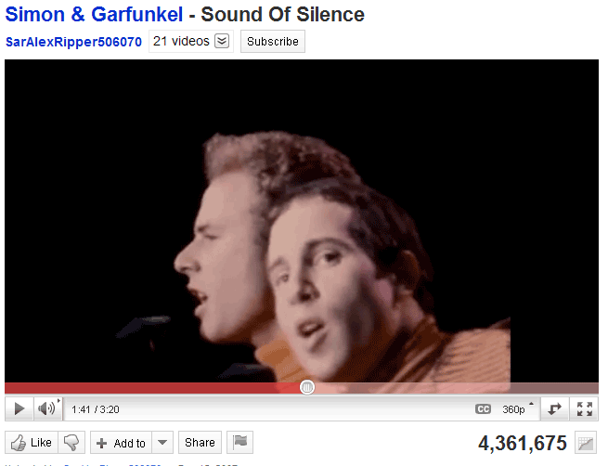

Hello darkness, my old friend, I've come to talk with you again
Because a vision softly creeping, left its seeds while I was sleeping
And the vision that was planted in my brain, still remains
Within the sound of silence

In restless dreams I walked alone, narrow streets of cobblestone
Neath the halo of a streetlamp, I turned my collar to the cold and damp
When my eyes were stabbed by the flash of a neon light, split the night
And touched the sound of silence

And in the naked light I saw, ten thousand people, maybe more
People talking without speaking, people hearing without listening
People writing songs that voices never shared, and no one dared
To stir the sound of silence

Fool, said I, you do not know, silence, like a cancer, grows
Hear my words and I might teach you, take my arms then I might reach you
But my words, like silent raindrops fell, and echoed in the wells of silence

And the people bowed and prayed to the neon god they'd made
And the sign flashed its warning in the words that it was forming
And the sign said the words of the prophets are written on the subway walls
And tenement halls, and whispered in the sounds of silence
Sound of Silence
Right click picture & click on Open Hyperlink
Turn up your surround sound
Do you get the picture now?

“Ordinary Americans have been manipulated into imagining they are a people under siege whose sole refuge and protector is their government. If it isn't the Communists, it's al-Qaeda. If it isn't Cuba, it's Nicaragua. As a result, this, the most powerful nation in the world — with its unmatchable arsenal of weapons, its history of having waged and sponsored endless wars, and the only nation in history to have actually used nuclear bombs — is peopled by a terrified citizenry, jumping at shadows. A people bonded to the state not by social services, or public health care, or employment guarantees, but by fear. This synthetically manufactured fear is used to gain public sanction for further acts of aggression. And so it goes, building into a spiral of self-fulfilling hysteria, now formally calibrated by the U.S government's Amazing Technicolored Terror Alerts: fuchsia, turquoise, salmon pink.” Arundhati Roy
— Arundhati Roy

